Printables.com’s “Unfolding James Webb Space Telescope (JWST)” – step-by-step printing and assembly guide

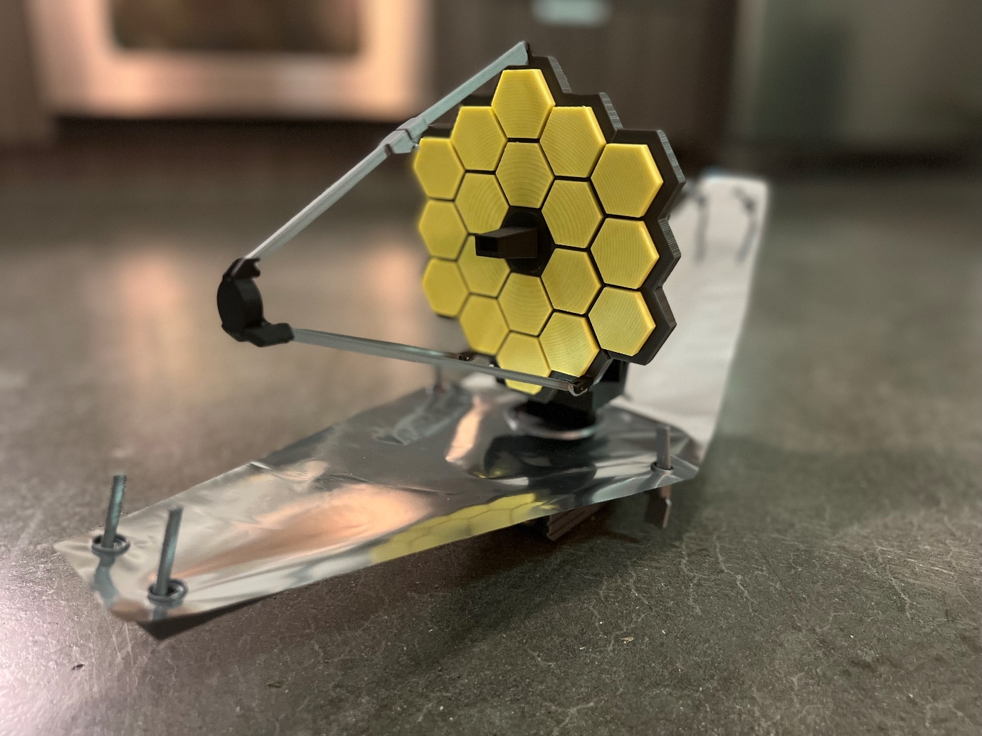
Model: https://www.printables.com/model/109816-unfolding-james-webb-space-telescope-jwst Author: https://www.printables.com/social/199859-chemteacher628/about
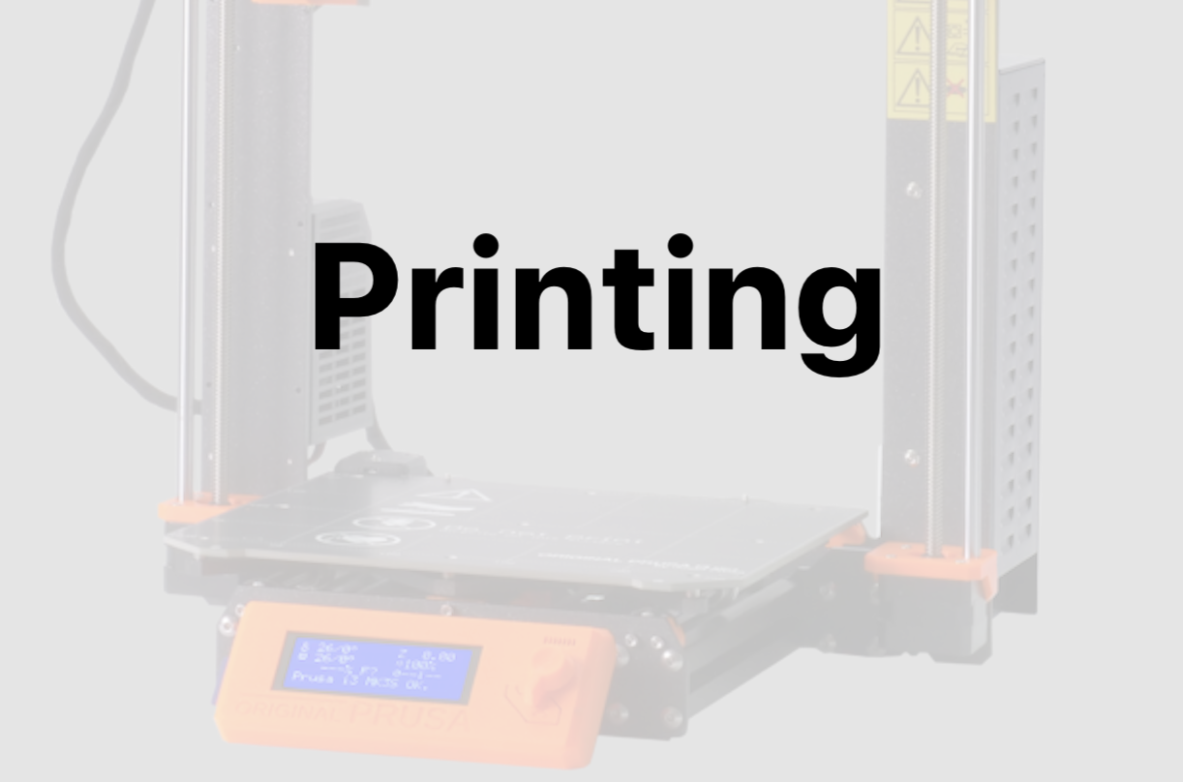

Section 1: printing all the parts. The steps in this section are numbered, but you can print the components in any order, of course. I printed most parts at 0.1 mm layer height, with a few at 0.05 for the most detailed elements. The print times mentioned are generally for 0.1 mm, but don't rely on them too much and check what your slicer predicts instead.

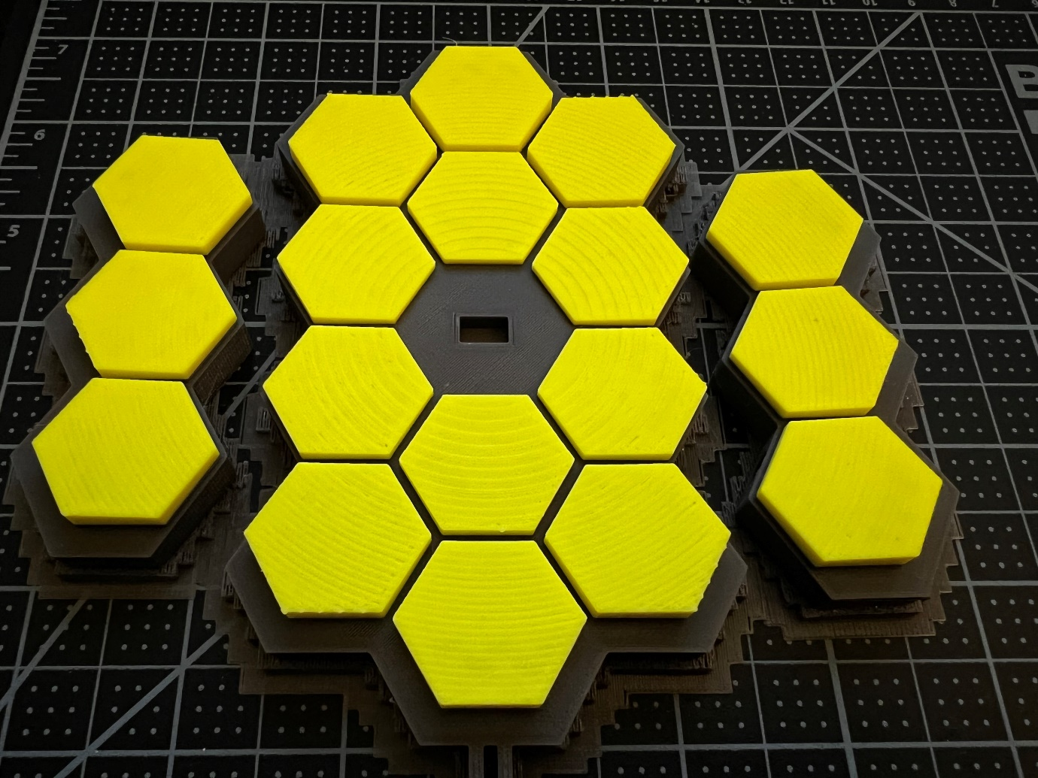

Above: the mirrors printed in 2 colors. To print the mirrors, you’ll need to arrange them so that their top surfaces (in yellow here) are parallel to the print bed. Their backs are *not* flat, so you’ll definitely need supports for those; but it’s also important to align their surfaces so that the finish is consistent between them. PrusaSlicer has a way to let you place a face of an object onto the print bed: https://help.prusa3d.com/article/place-on-face-tool_1781 Here, it’s pretty difficult to place any part of the back onto the print surface, because there are many faces to choose from on that rounded back. What you can do instead, is to place the *top* of the mirror – the flat yellow surface here – onto the print bed for all 3 elements of the mirror, and then once they’re aligned this way, flip them 180 degrees so that their backs are on the surface and the mirrors face up. Once they’re aligned, make sure to add a “color change” step in the print. This is how to do it: https://help.prusa3d.com/en/article/color-change_1687

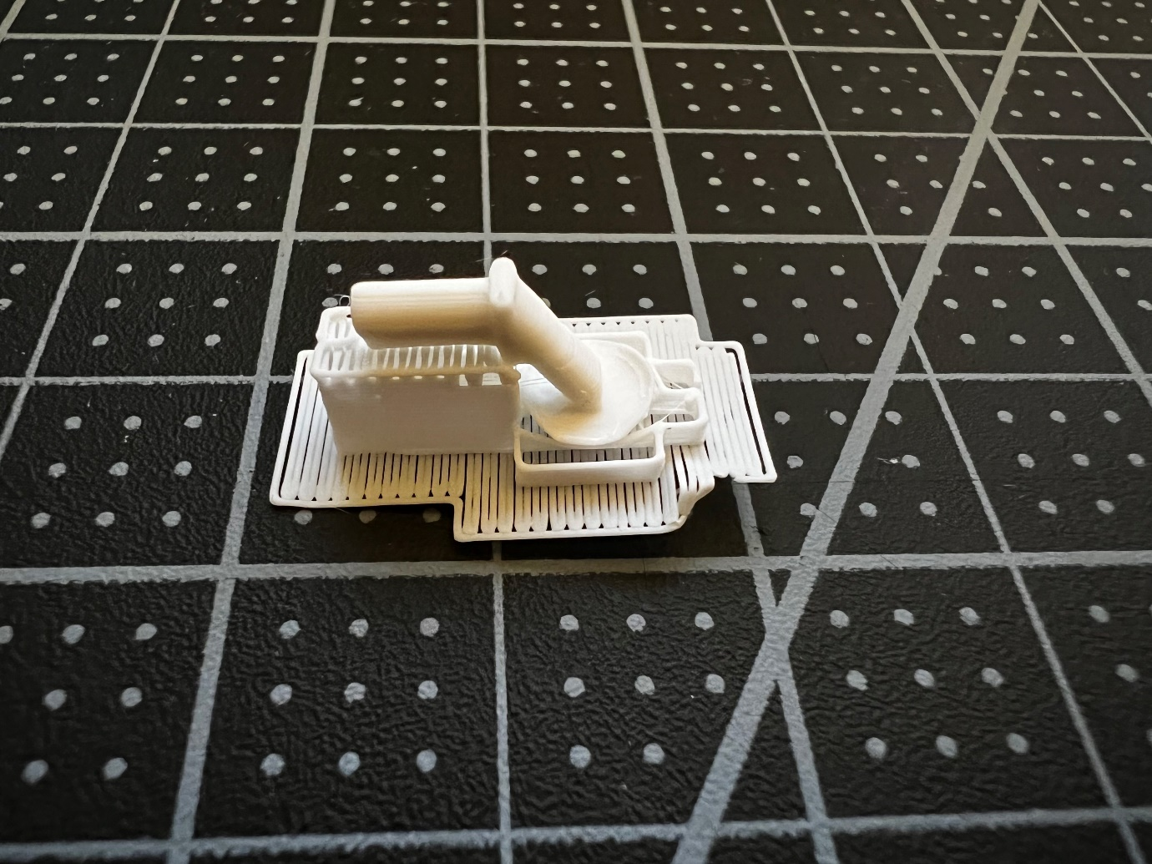

Step 2: print antenna.stl with supports in white (print time: 8m).

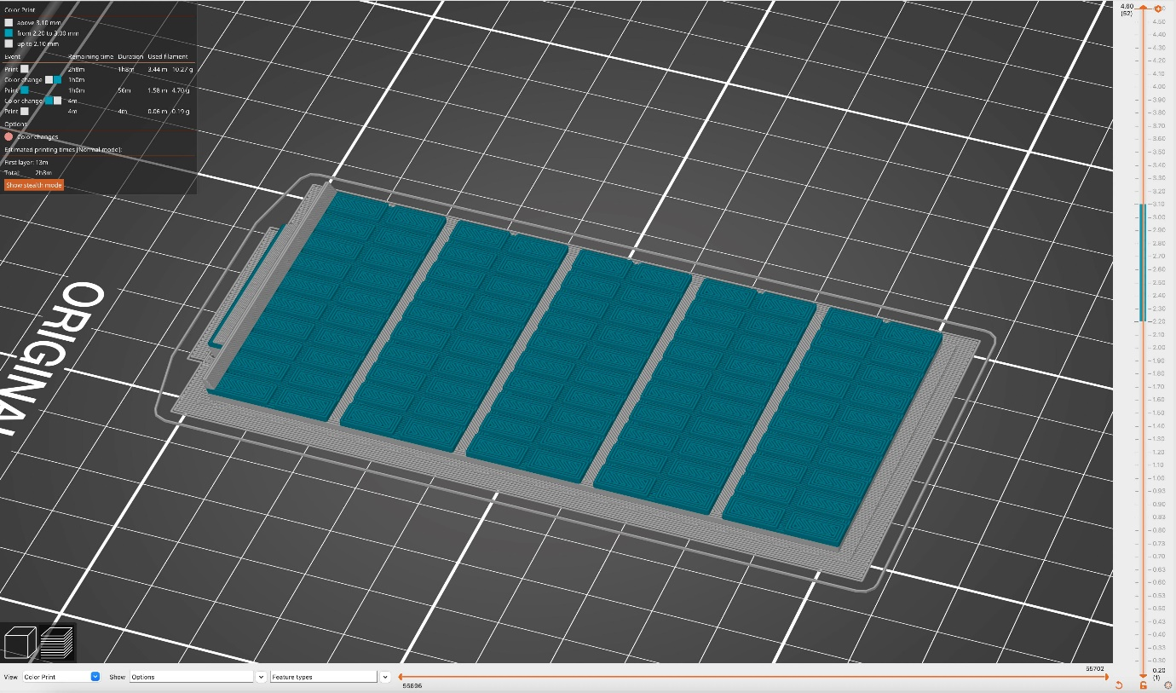
Step 3: print solar-panel.stl with supports in light grey, then switch to blue (or dark blue) when the z-height reaches the panels themselves; see this link for a rendering of what they look like: https://www.labmanager.com/news/sunshield-successfully-deploys-on-nasas-james-webb-space-telescope-27327 or what they actually look like in this photo from NASA: https://www.flickr.com/photos/nasawebbtelescope/48799769808 Make sure to place the flat face on the print surface so that the photovoltaic panels (the blue part) are on top of the base, then split by color like for the mirrors above. The base should be flush with the print bed, or very close to it. Then with the base in grey, add a color switch to blue at 2.20mm and another back to grey at 3.10mm so that the "lip" on the left side isn’t all blue (print time: 2h). ⚠️ I'm not 100% sure that this part needed supports, you might find that it prints well without them. In my case, the supports were very difficult to clean up.

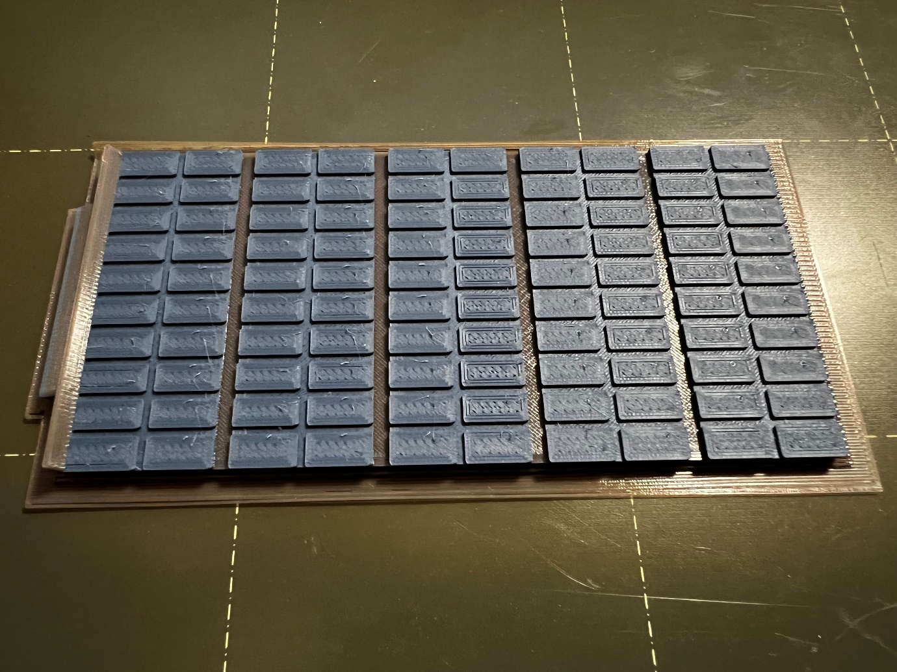

Step 3, result: note the grey base, dark blue cells, and again grey raised edge on the left. If we had done only grey→blue and not grey→blue→grey, that part would be blue as well. I printed the blue layer in dark blue, but I’m considering re-printing it in a lighter blue color to make the photovoltaic panels "pop" more against the grey surface. The real panels are almost black though… well, pick whatever color makes sense to you!

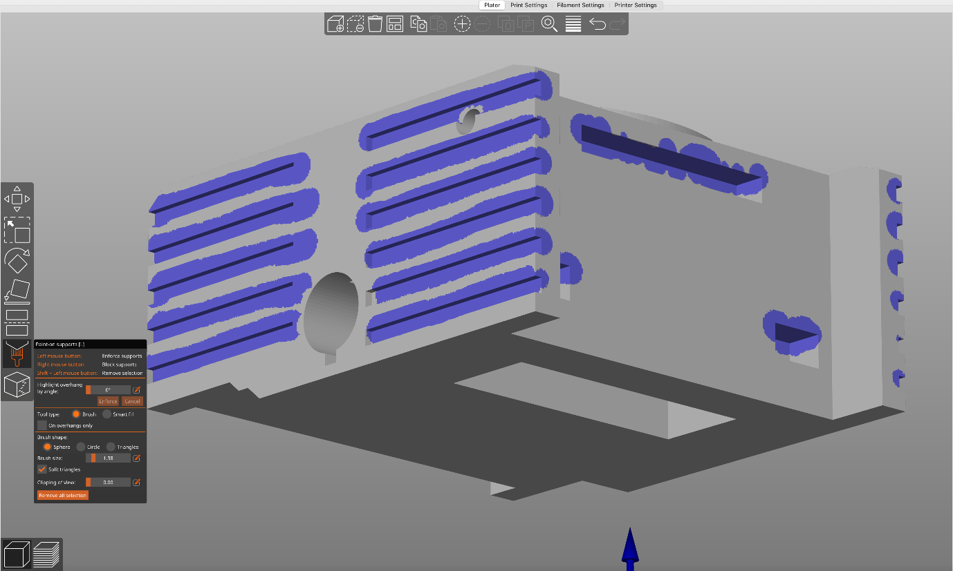

Step 4: open main-body.stl and place the flat face on the print surface, so that the segmented “ring” is on the top. Print it (with supports) in light grey almost all the way to the top, so that the whole body is light grey but then switch color to black as soon as the segmented ring starts (on my printer at 0.1mm, that’s a color change at z=31.70), and then change to blue at z=32.90. Finally, add a third color change at z=33.10, switching to black again. Note that I also added "paint-on supports" for all the rectangular slots that created overhangs, although I’m not sure this was really needed (print time: ~9h). Prusa help page on paint-on supports: https://help.prusa3d.com/en/article/paint-on-supports_168584

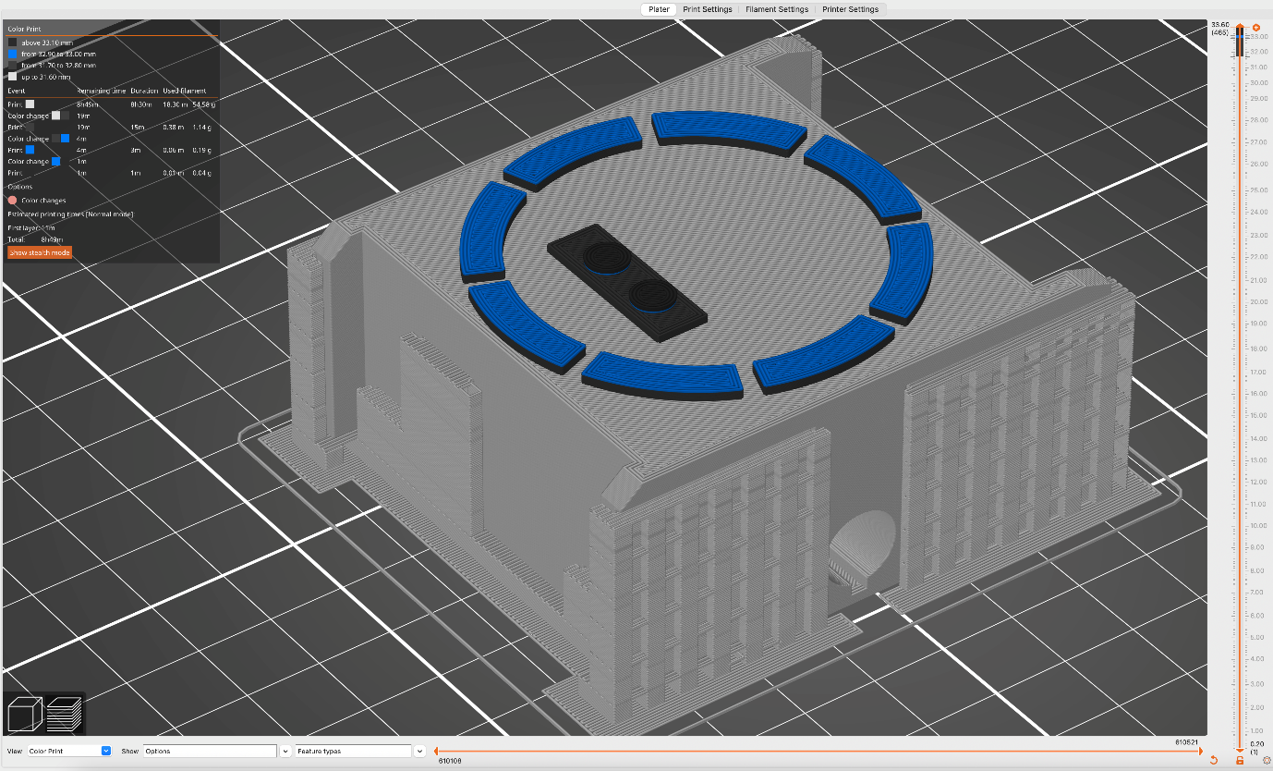

Step 4, preview. Note the 3 (!) color changes, grey→black→blue→black; for reference their z-heights are mentioned here again at the top left.

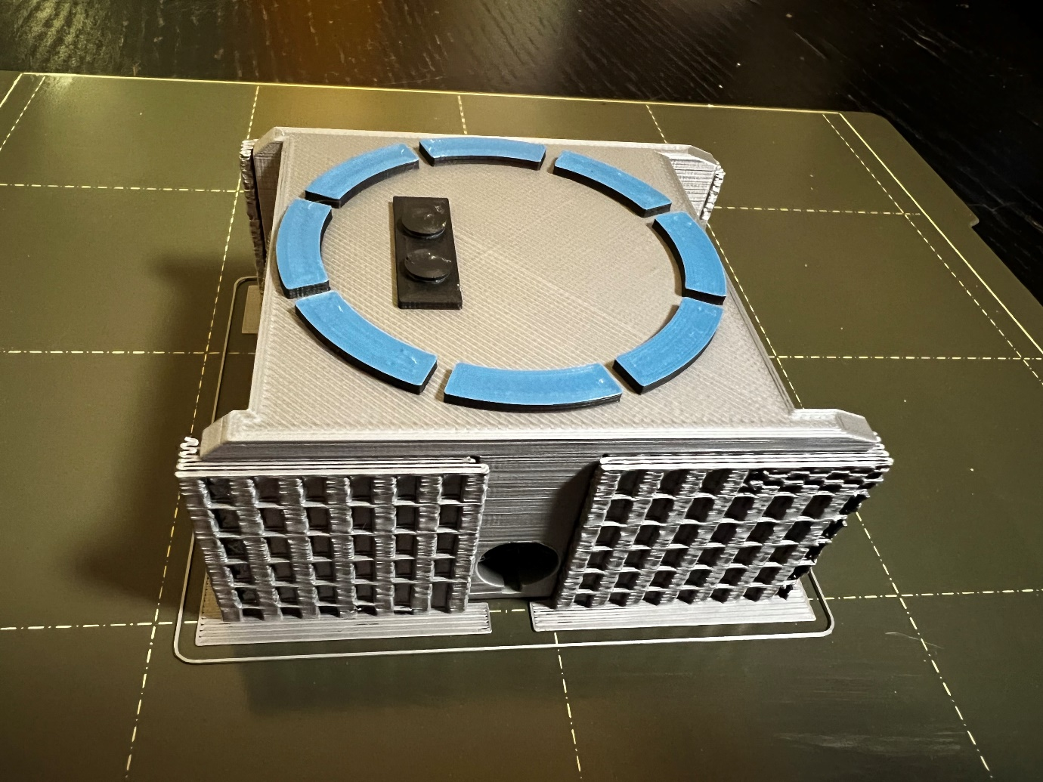

Step 4, result: a 3-color part. The circular holes turned out well, I’m glad they didn’t need supports.

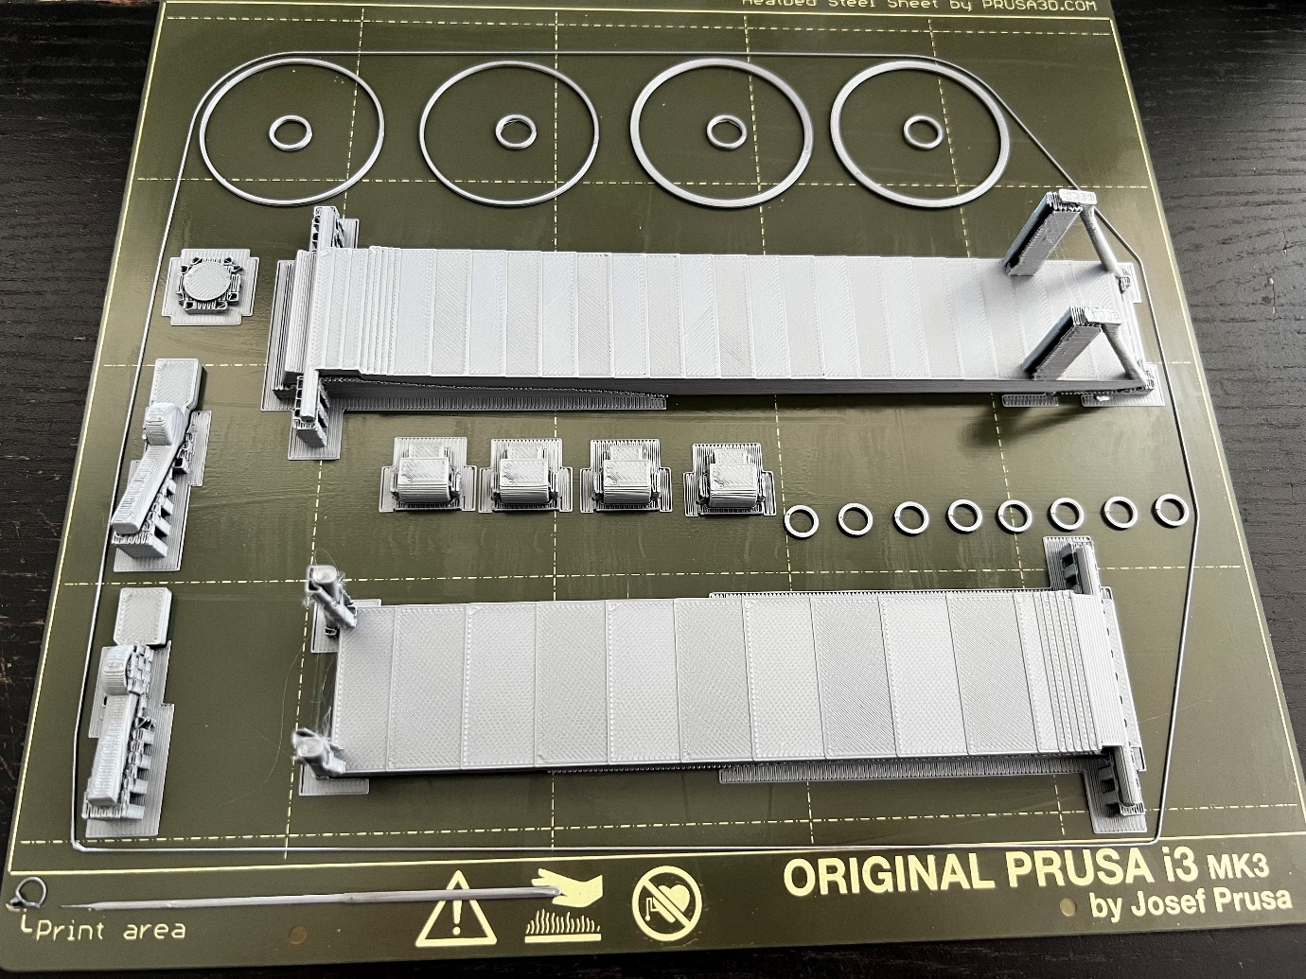

Step 5, print the following in a single batch, in light grey: aft-shield.stl fore-shield.stl l-boom-end-post.stl left-boom-cap.stl mirror-shield-washer-2x.stl (optional, you can also just go with washer-v2) mirror-shield-washer-v2.stl (so just this one) r-boom-end-post.stl shield-panel-hinge-4x.stl shield-washer-large-4x.stl shield-washer-small-8x.stl For each one, press "F" with the object selected, and make sure to place a (relatively) flat face on the print surface whenever possible. Also, make sure to follow the instructions in the filename and copy/paste the elements for which multiple copies are needed. ? With PrusaSlicer, you can right-click on an element and select "Set number of instances…" before entering the number of copies you want. This makes it easier than copying and pasting parts. To be clear: the way you batch elements to print is up to you, this is just how I did it and it worked for me. I’m sure you could cram a whole lot more than I did on the platter. Photo: result of the print (print time: 8½ hours)
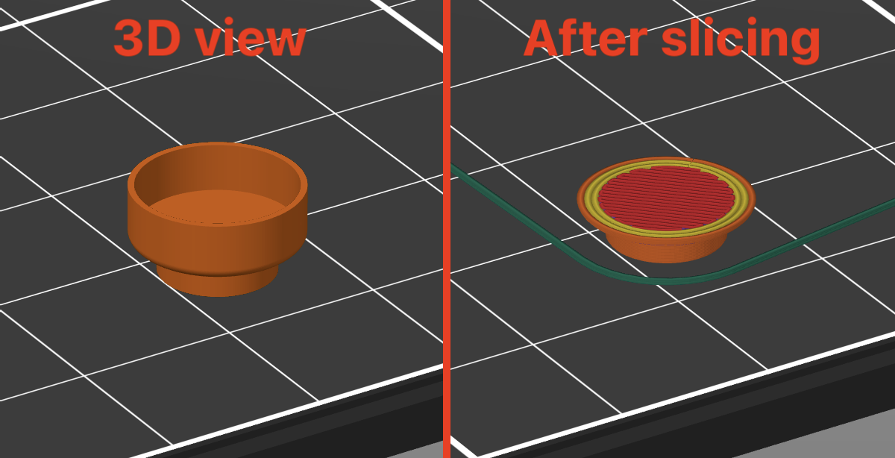

⚠️ Pay close attention to left-boom-cap.stl: it has a thin wall, which by default in my version of PrusaSlicer was sliced in a way that did not include paths for it in the G-code. You can use the Preview render to check that it was sliced as expected. To fix this issue, enable "Detect thin walls" in "Print Settings" and re-slice. In the previous photo, you’ll see that I hadn’t noticed this issue at the time and printed it incorrectly (it’s the flat piece at the top left); I re-printed it later once I realized what had happened.

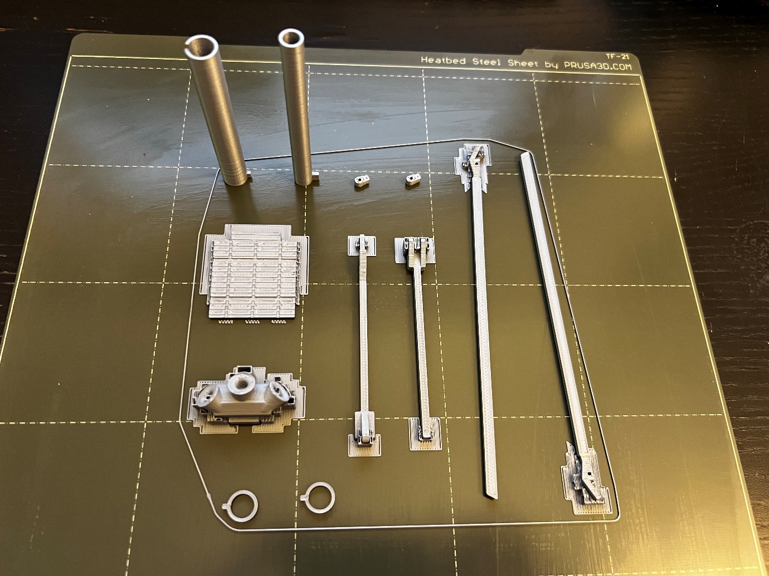

Step 6, print the following in a single batch, in light grey: aft-momentum-flap-hinge-2x.stl aft-momentum-flap.stl boom-left.stl boom-right.stl center-secondary-mirror-strut-main-mirror-side.stl center-secondary-mirror-strut-secondary-side.stl l-secondary-mirror-strut.stl r-secondary-mirror-strut.stl Star Trackers.stl (previously called thrusters.stl) washer-boom-2x.stlbak-of-mirror-strut-2x.stl I would recommend printing the boom arms vertically, otherwise you’ll have to deal with supports that will leave unsightly marks and will be difficult to clean up. Again, make sure to attach some flat face to the print surface for each object. Photo: result of the print (print time: 3h).

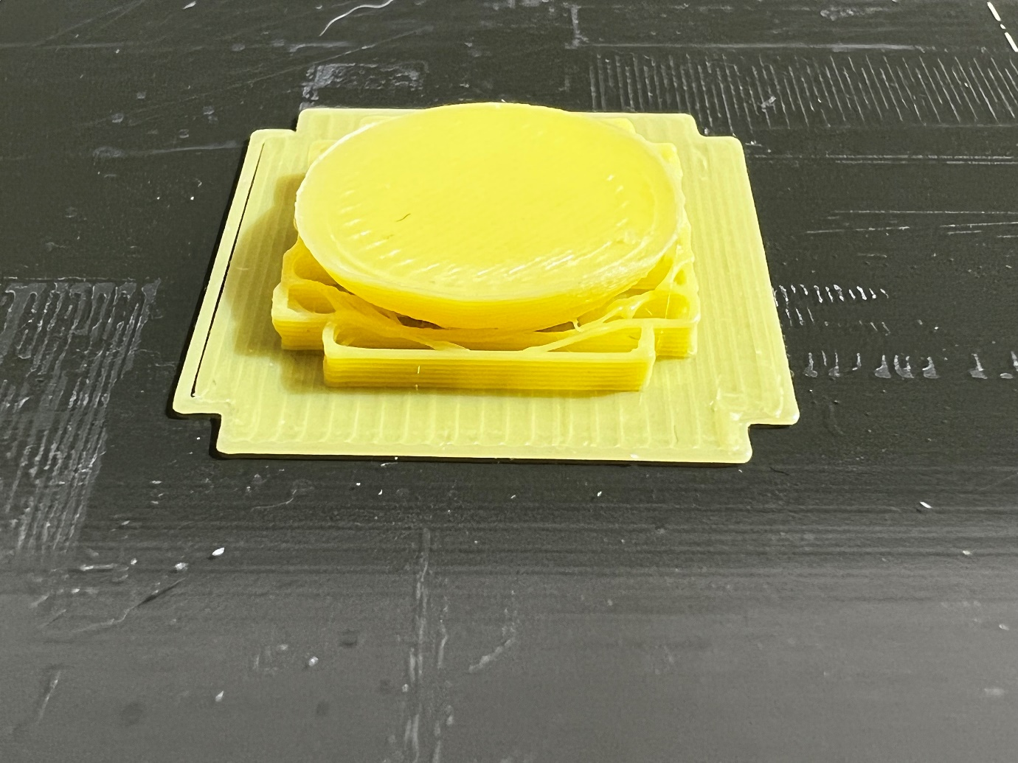

Step 7: print secondary-mirror.stl in yellow/gold, with the flat surface on the print bed (not like in this photo). This is a yellow version, I ended up re-printing it with gold-colored filament later, I thought it looked better that way. Pick whatever makes sense to you based on what you have available :-) I printed it in 0.05mm to try to retain as much of the curvature as possible (print time: 12m).

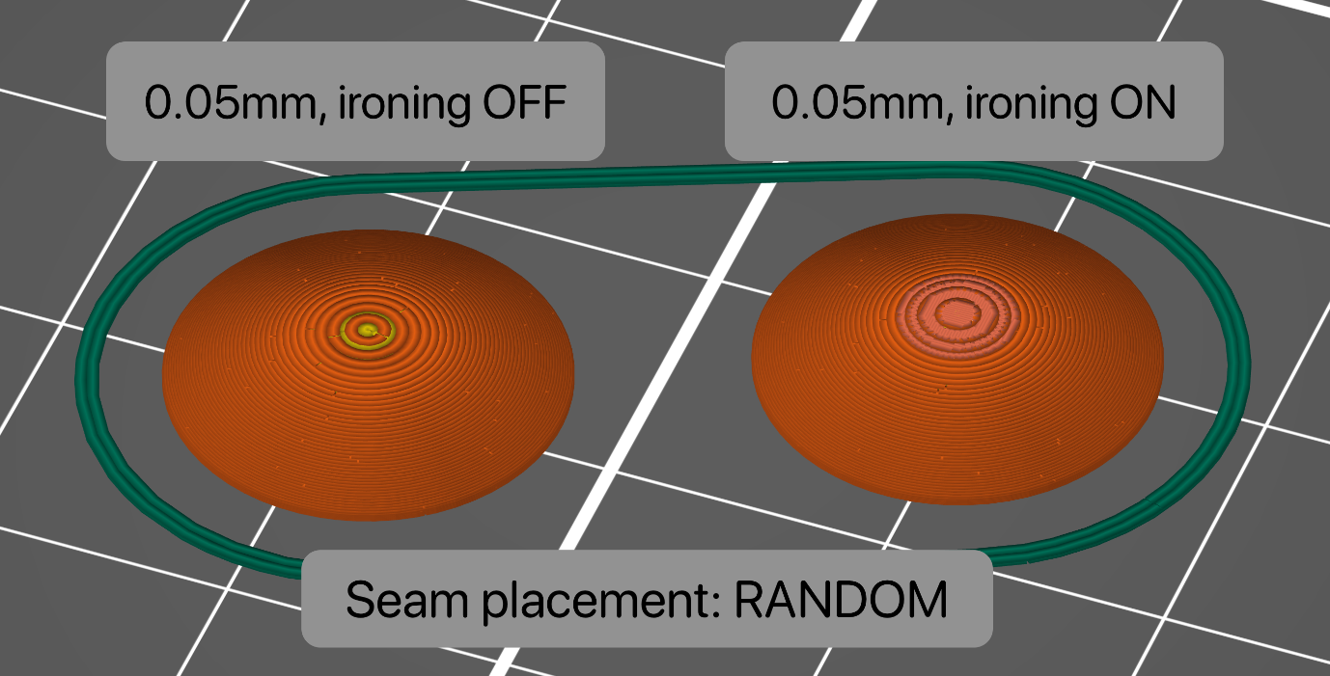

I had originally printed it with supports withe the curved surface toward the print bed (as shown previously) but removing the supports caused the rounded surface to be pretty rough and uneven. I decided to print this part again, this time with no supports and the flat surface on the print bed. Here, there are two more settings I thought could make a difference. One is “ironing”, a relatively new feature in PrusaSlicer where the slicer will generate G-code to “fill in” the top surfaces so that they do not exhibit this typical pattern of lines so often seen on 3D prints. With ironing on, you should have a very smooth surface instead. The second setting you might want to experiment with is the placement of the “seam”. When the printer generates loops like for printing a vase for example, each loop has to start and end somewhere. If all the loops start and end at the same place, you might get a visible vertical “seam” on the object. Indeed if you leave the default settings and look at the resulting preview in PrusaSlicer, you’ll notice a series of dot or bumps climbing up the mirror. You can try changing the Seam Position setting to “Random” instead of the default “Nearest” to avoid these artifacts. For this object, the extra print time incurred is negligible. See this help page for more info: https://help.prusa3d.com/article/seam-position_151069
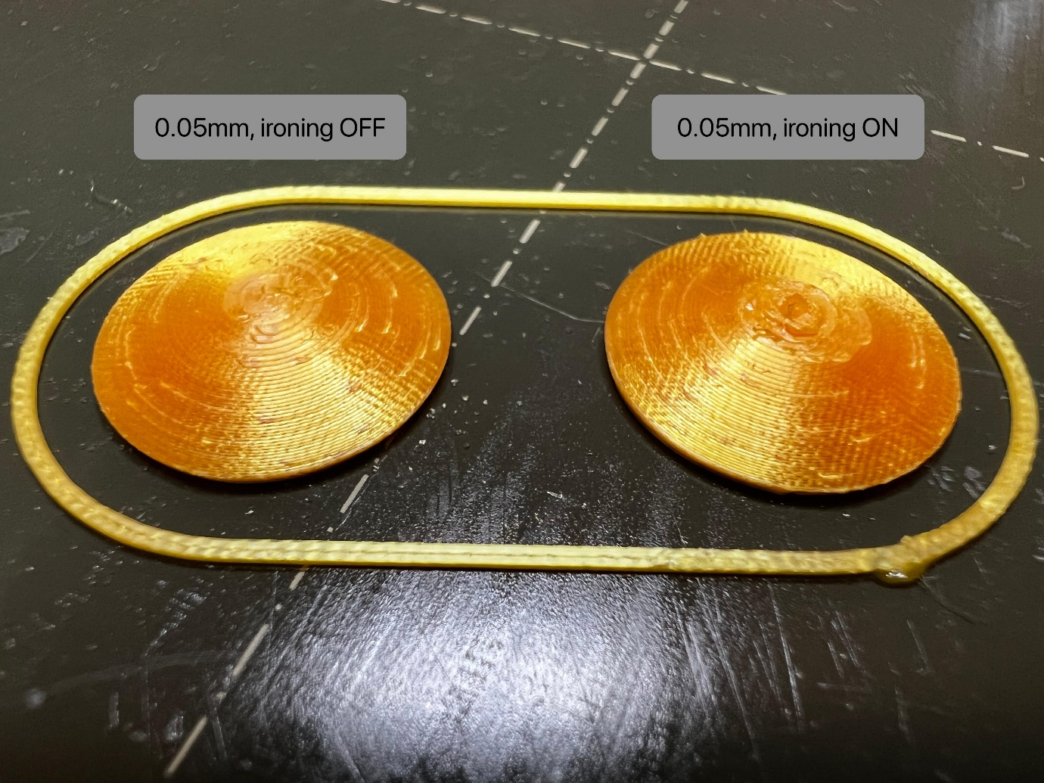

Result: the part with ironing on looks worse; it made the center have more of a lump than a smooth surface. For this reason, I would recommend keeping ironing OFF for this part. The random seam did cause some *tiny* surface aberrations, but this is unlikely to be noticeable once the model is assembled.

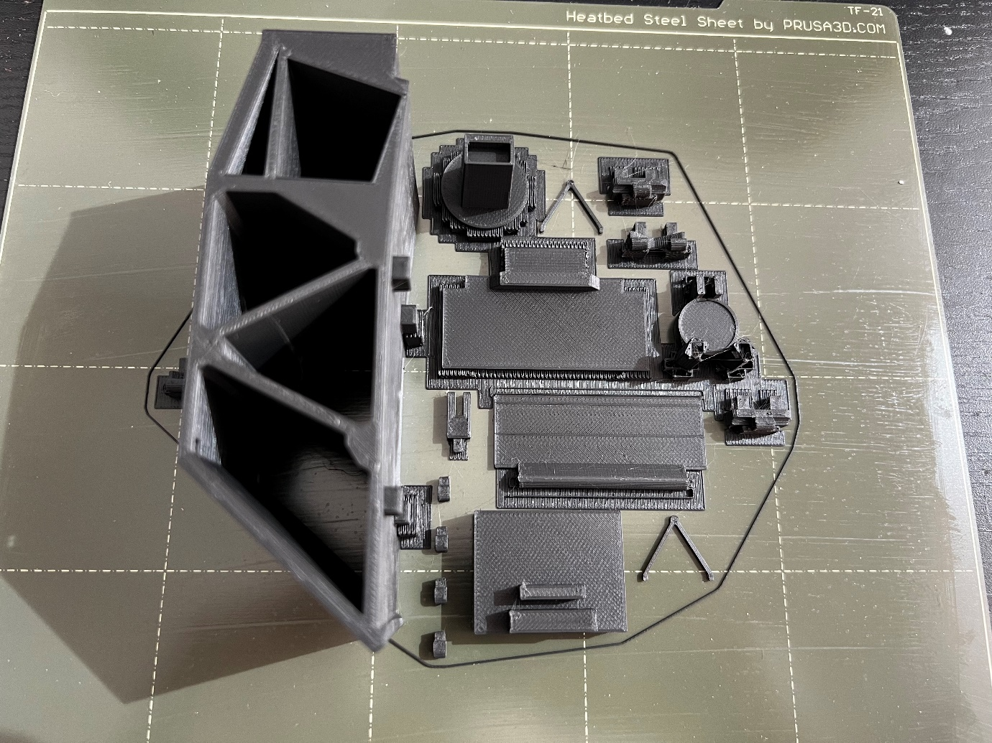

Step 8: print the following in black, aligning faces onto the print bed whenever possible: back-panel-bottom.stl back-panel-hinge-4x.stl back-panel-top.stl l-mirror-hinge-center.stl l-mirror-hinge-side.stl light-collector.stl mirror-scaffold.stl mirror-tower.stl r-mirror-hinge-center.stl r-mirror-hinge-side.stl secondary-mirror-frame.stl secondary-mirror-hinge-bottom-front-of-mirror-2x.stl For mirror-scaffold.stl, instead of placing a flat edge onto the print bed I printed it on its side in order to avoid needing supports for the large overhangs. The photo shows bak-of-mirror-strut-2x.stl in black, this was a mistake and I later re-printed it in grey. I used matte black for these pieces, but a more shiny black would probably work well too (print time: 11h).

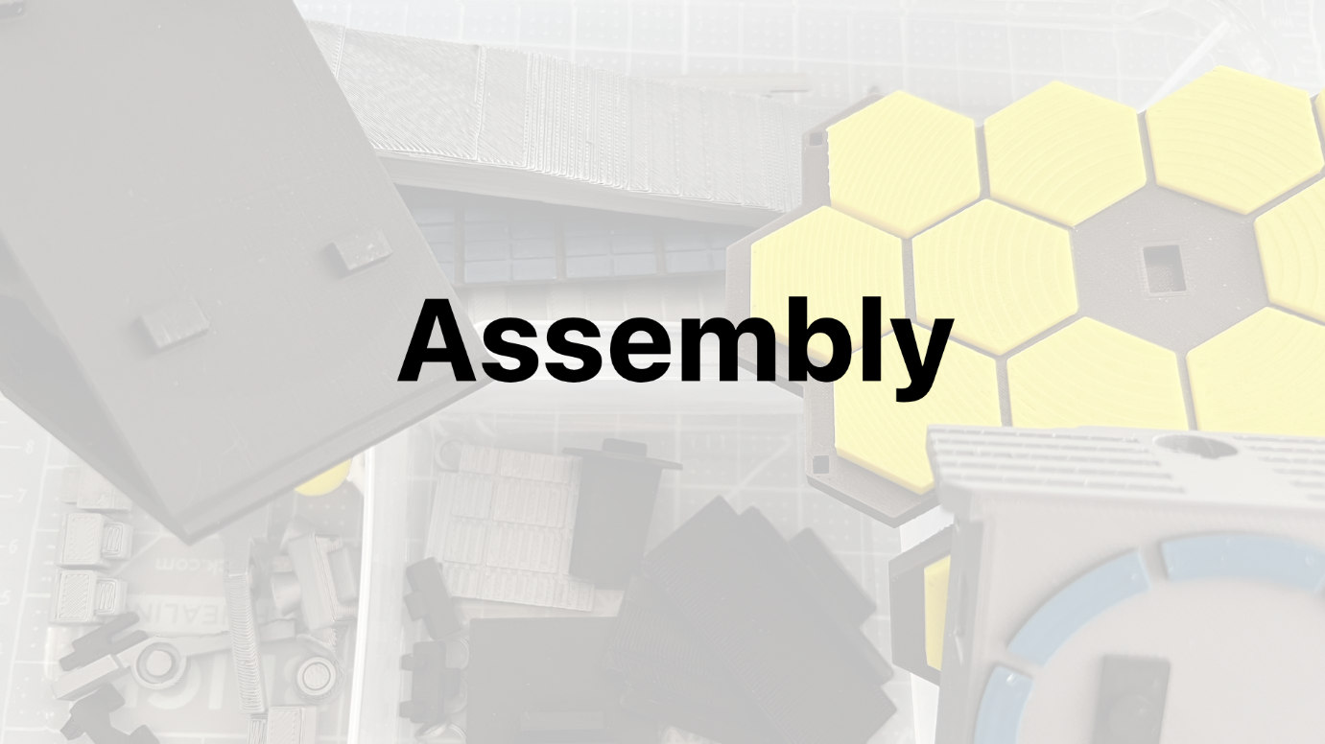

Section 2: assembly

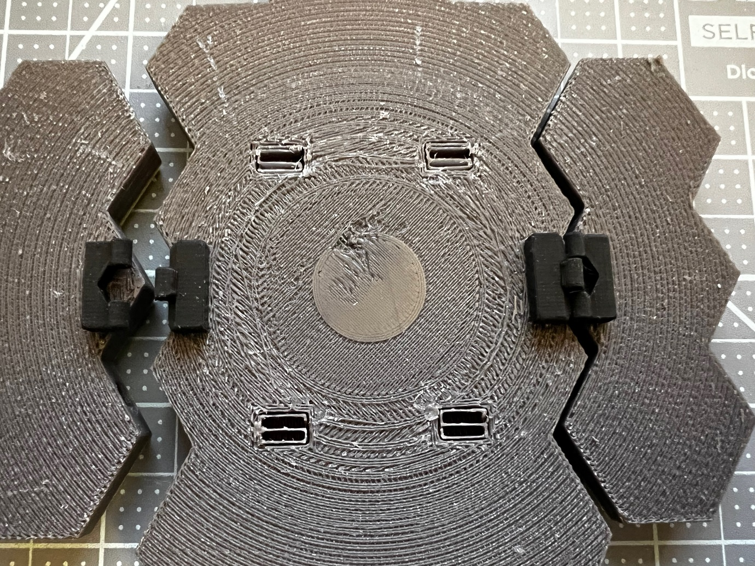

Insert the hinges in the back of the mirror elements. Don’t forget to remove the supports from the 4 holes in the center element! They are still visible in this shot but will need to be removed.

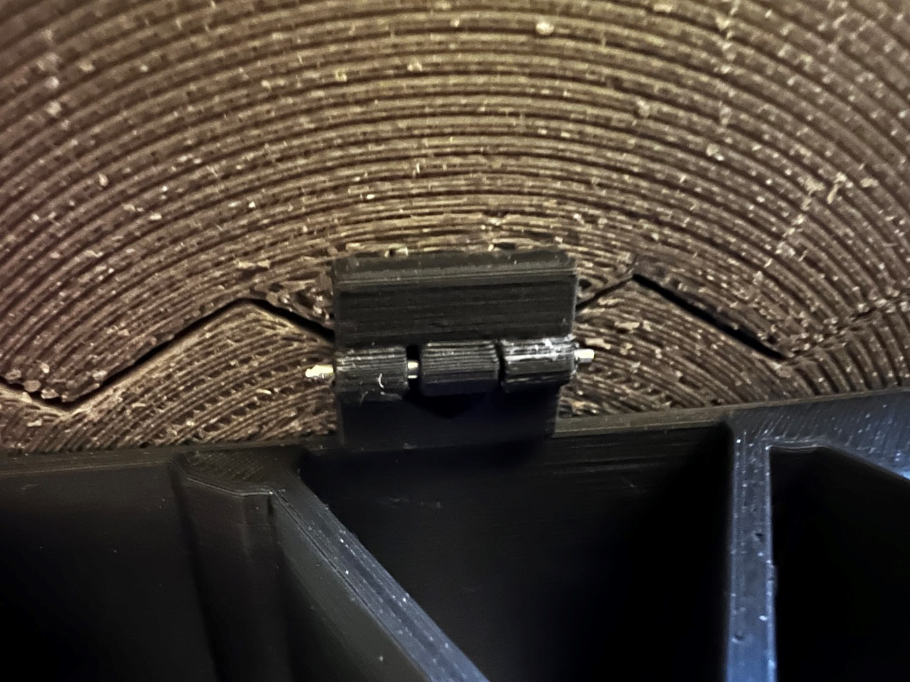

Cut small pieces of piano wire to the right length and insert them in the hinges. I used piano wire "size 21" which is 0.047 inches in diameter, or 1.19 mm. I found that the 1.25 mm nails I had were generally too wide for this purpose, although I did manage to use them in a few places. ⚠️ If you decide to use piano wire for hinges, you’ll need a tool to cut it. The video on Prusa’s YouTube channel shows someone using an angle grinder; while this will definitely do the job, you’ll want to avoid damaging your tools if you don’t have one. Don’t expect simple pliers to be able to cut through piano wire. I used a wire rope cutter rated for 6mm cables, which worked well for me (this cutter: https://amazon.com/gp/product/B08342GD58 – not an affiliate link, by the way). Note, this photo was taken later during assembly and shows the black scaffold; at this stage you should have only the mirrors linked by their hinges.
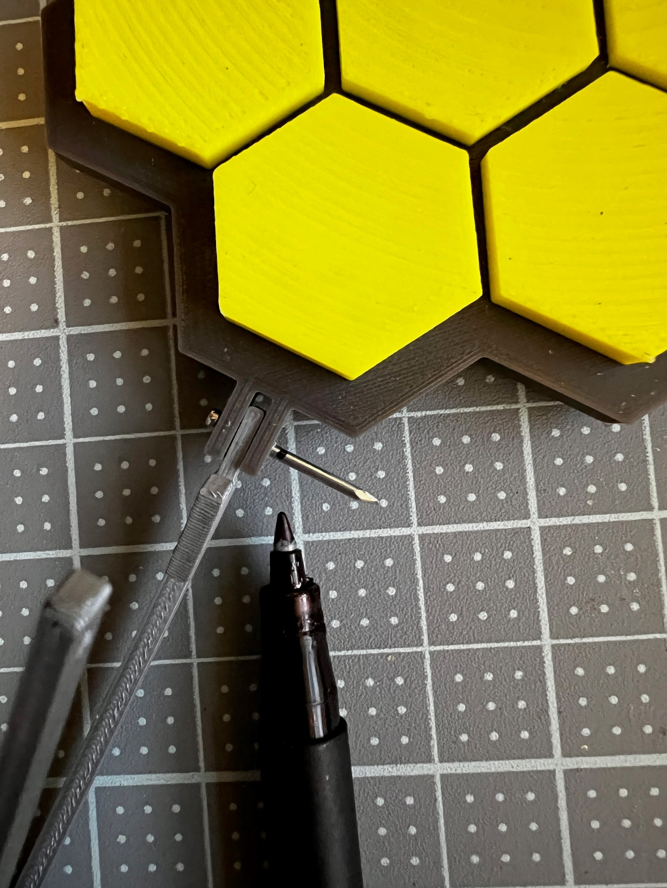

This is one of the places where I did manage to use a nail, but I’m not super happy about the amount of friction it produces. Find what works for you! If I had to replace this part I’d probably use piano wire here instead.

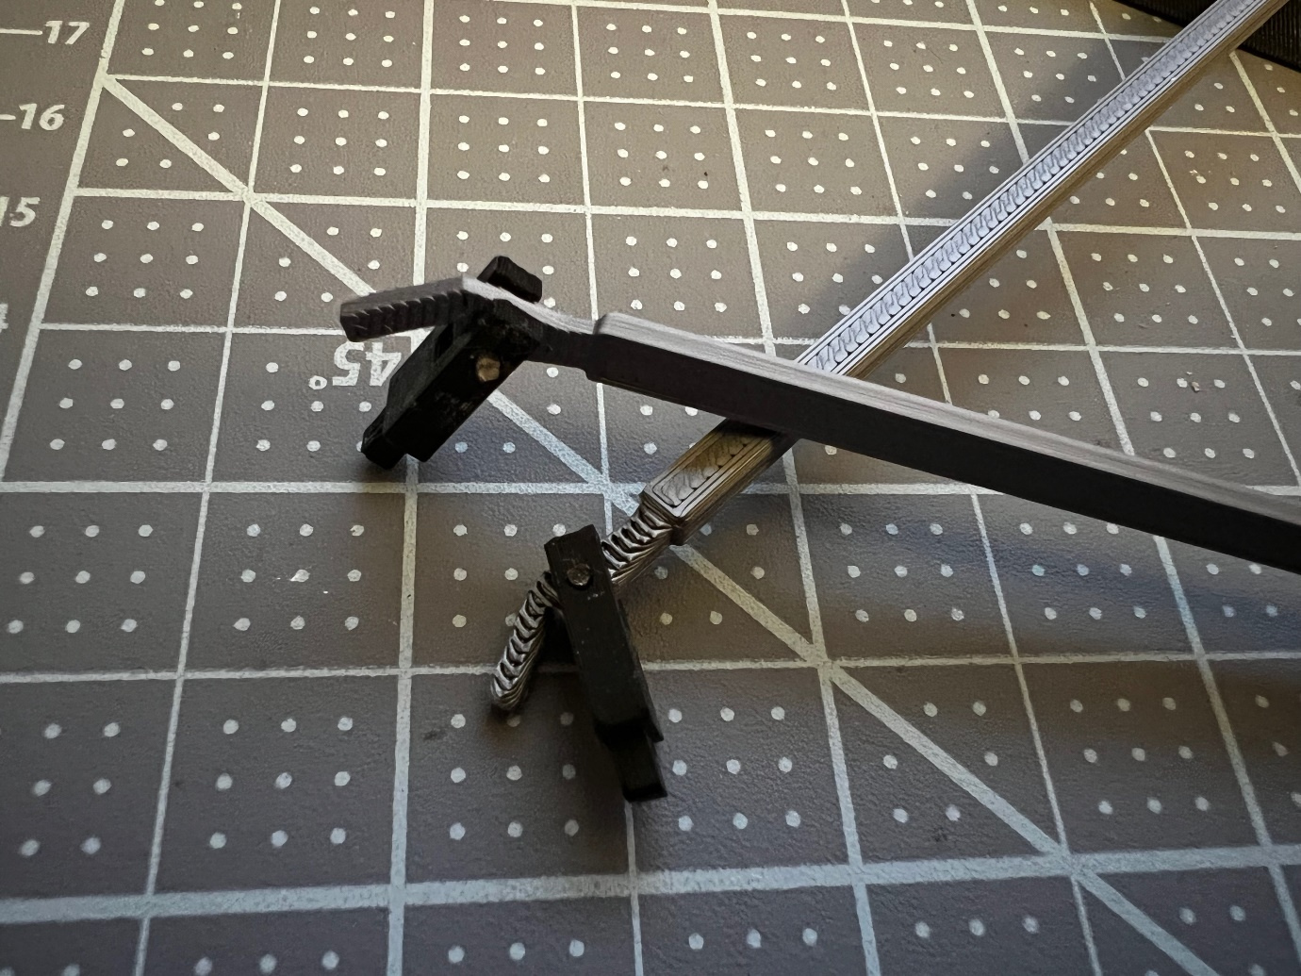
And the two side struts (l-secondary-mirror-strut.stl and r-secondary-mirror-strut.stl) being attached to their connectors (secondary-mirror-hinge-bottom-front-of-mirror-2x.stl). I used piano wire for these.

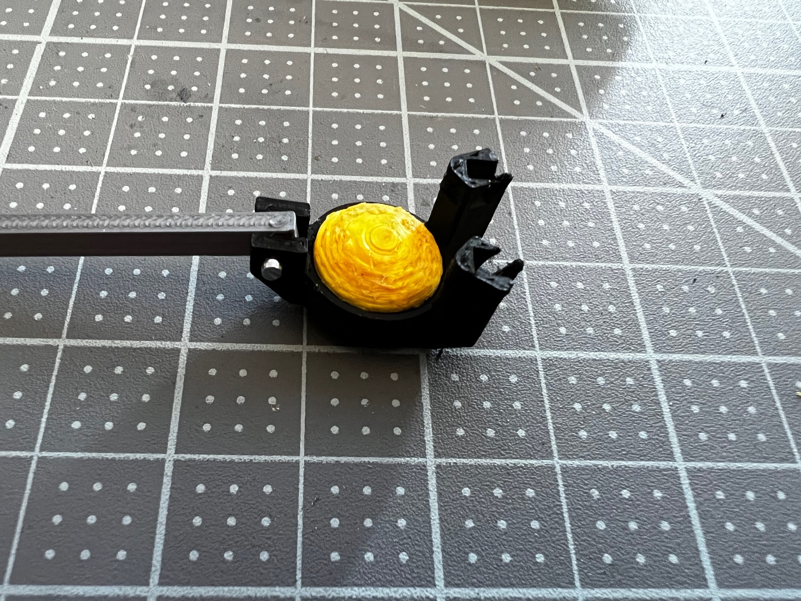

Glue the reflector (secondary-mirror.stl) to the 3-point connecting element (secondary-mirror-frame.stl) and attach its central connector to the part of the folding strut that’s still not connected to anything.

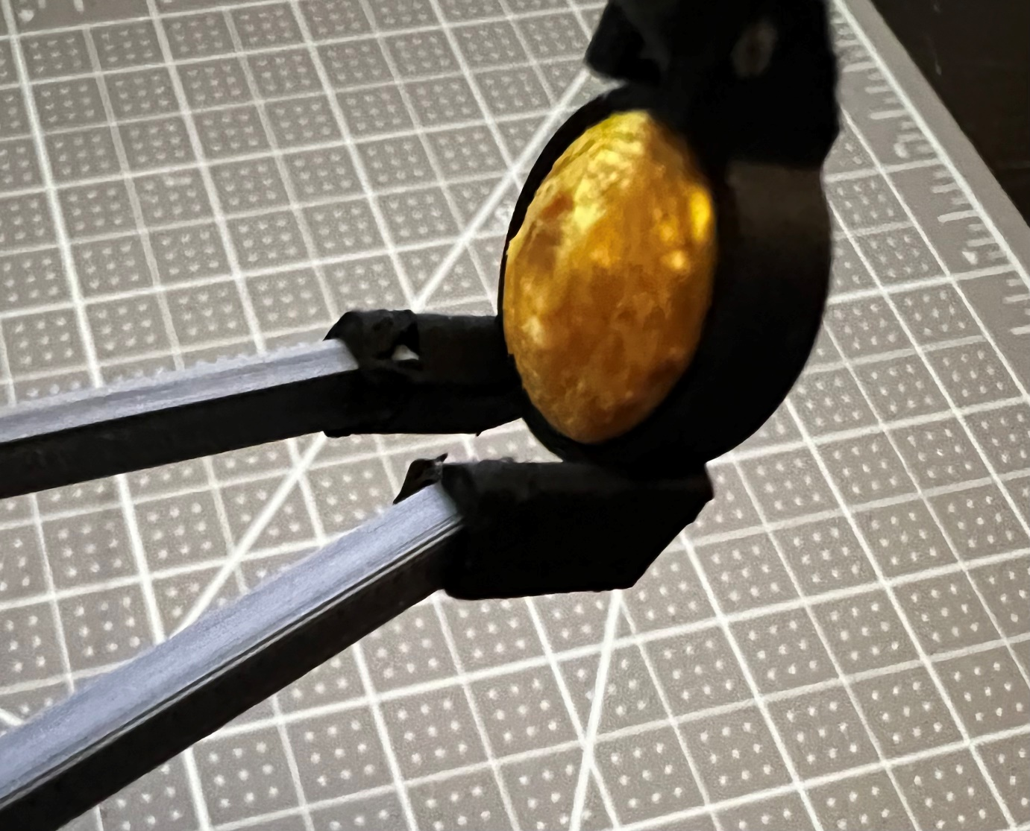

The two arms slot into the connector holding the reflector. They come in at a weird angle, kind of spreading outward. Be careful! This connection point is particularly fragile, with very little material covering the end of the struts.

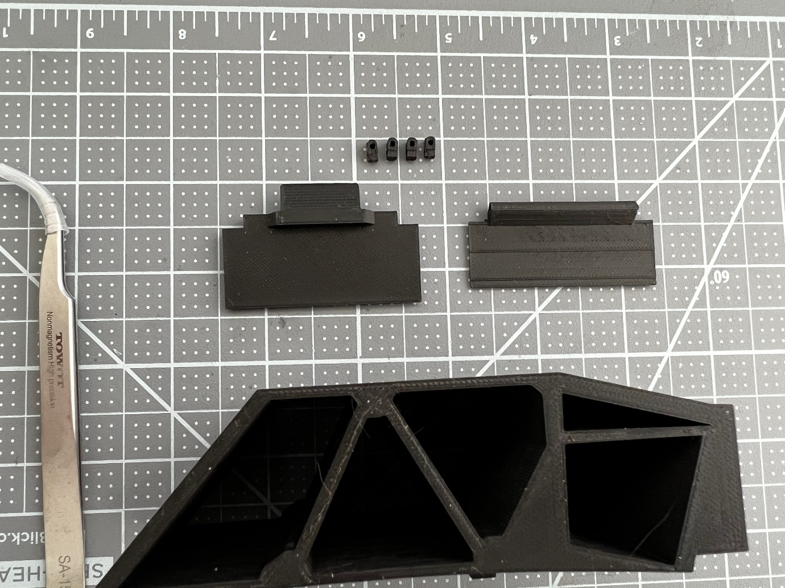

Next, the back of the telescope. Grab the two flaps and the 4 nubby connectors, and glue them to the 4 holes at the back.

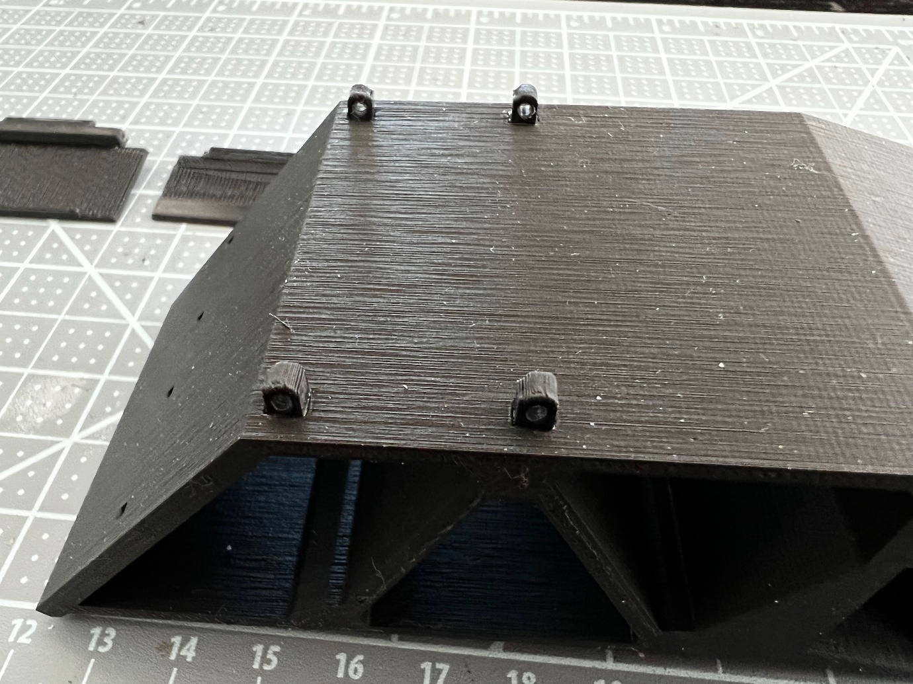

In place after glueing.

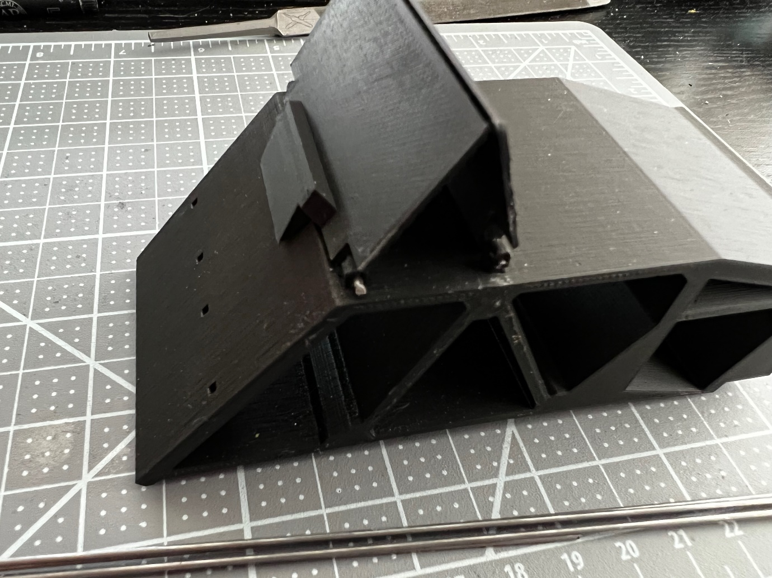

Attach the two flaps and insert piano wire in the hinges. They are different, make sure to have the one with a protruding "lip" in the correct position as shown.

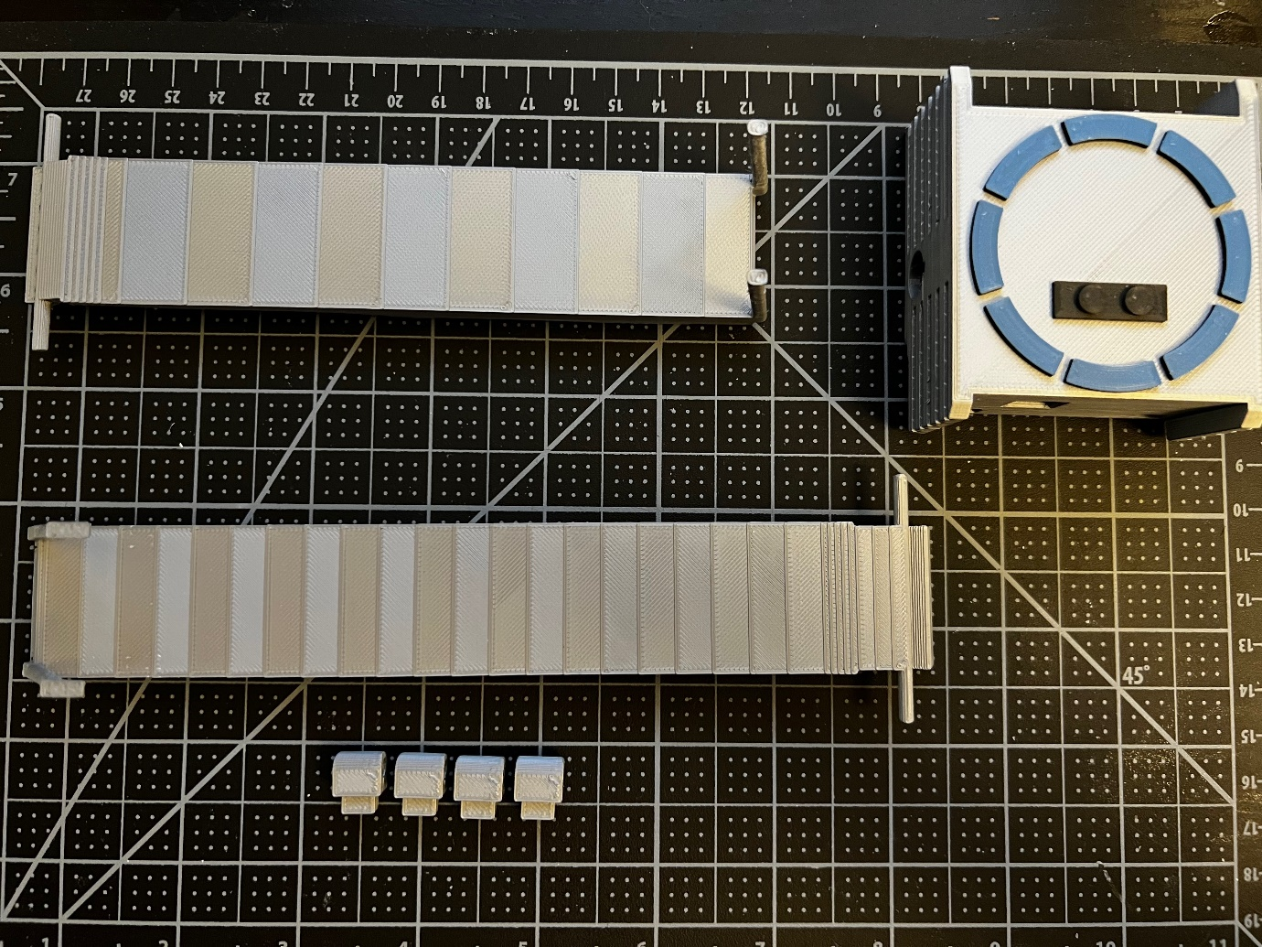

Let’s start attaching the fore and aft shields to the main body, using the 4 grey connectors. The fore shield (front side) is the one with straight "poles" sticking out of it, while the aft shield (back side) is the one with angled poles and "feet" on them.

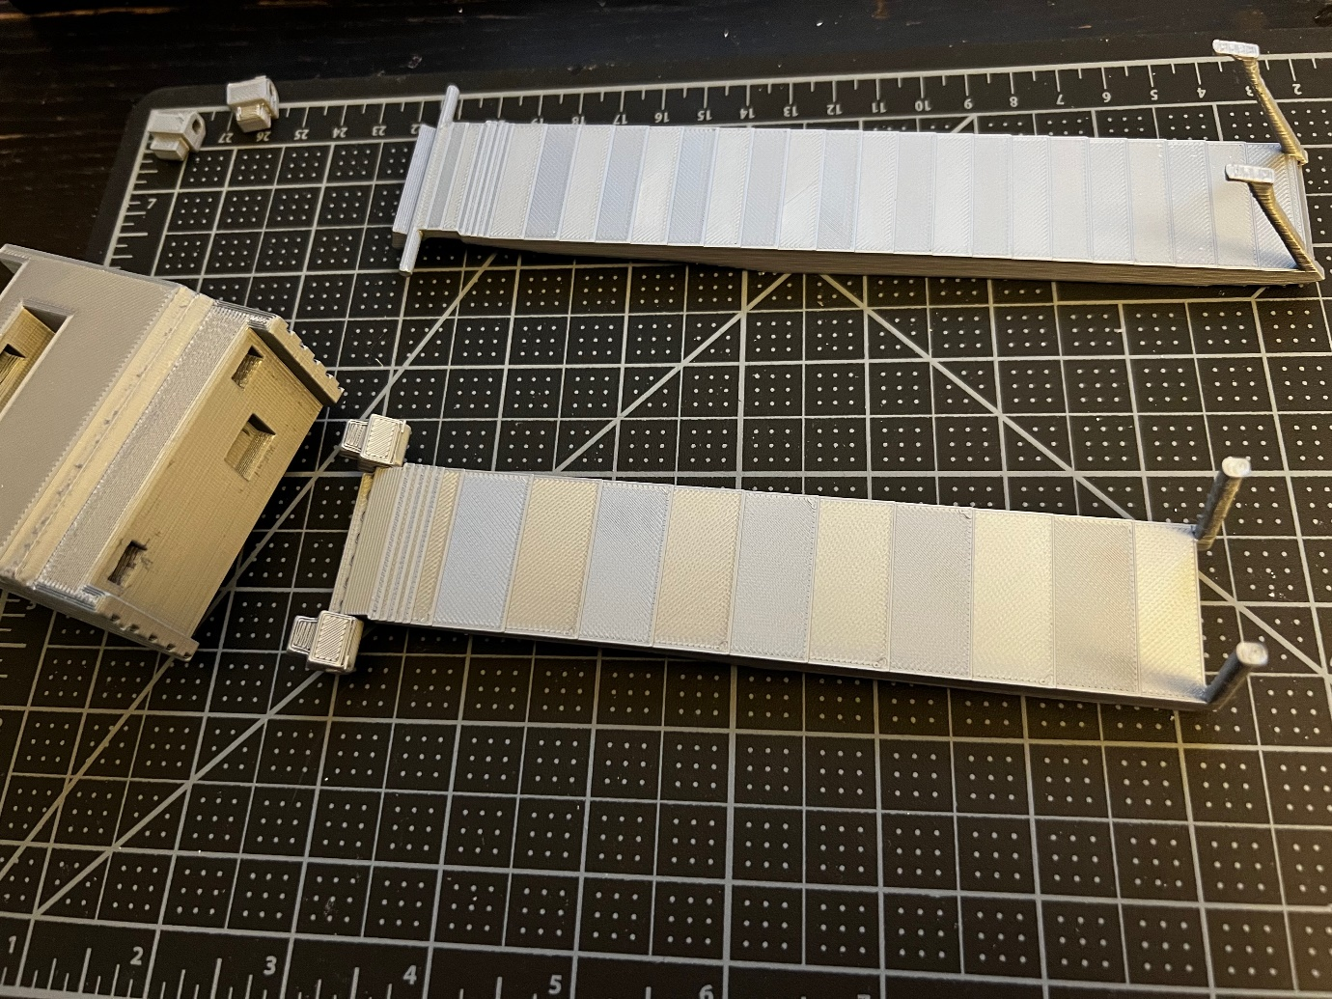

The fore shield with its connectors attached, showing where they’ll be inserted into the main body. For both shields, start by mounting the connectors to the protruding "rod", and then attach the whole thing to the main body. I didn’t need glue for these, figure out for yourself whether there’s enough friction for them to hold in place. Grab the solar panel at this point, we’ll also attach it to the main body.

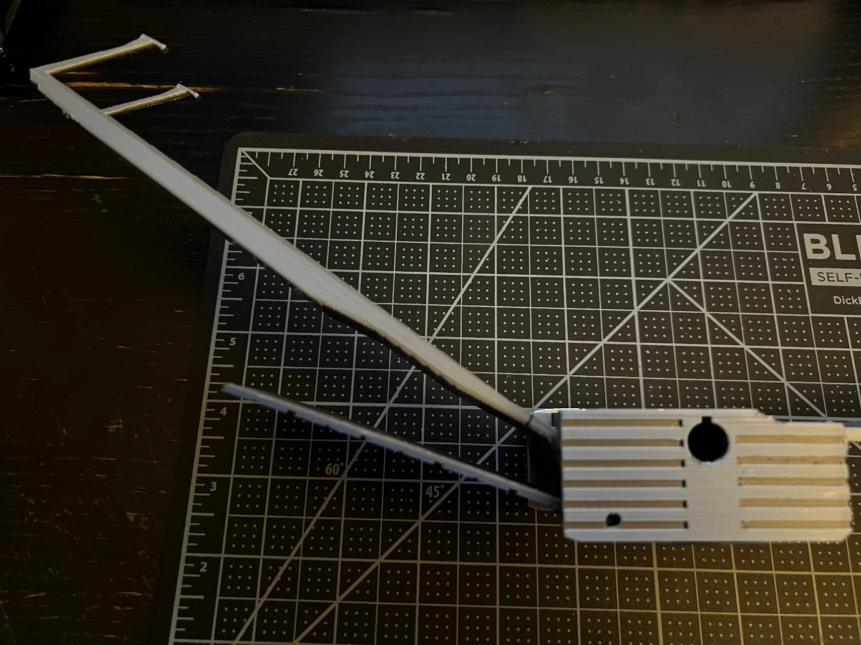

Aft shield connected, as well as the solar panel.

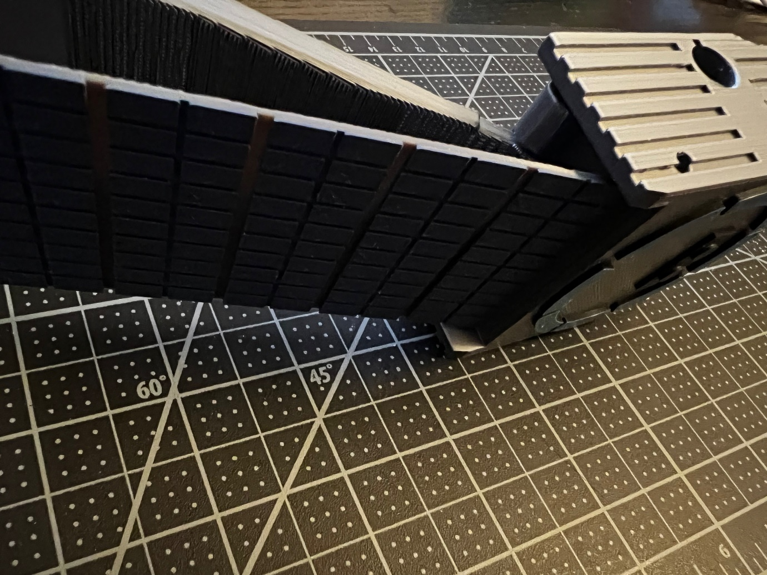

Another view of the solar panel under the aft shield — sorry it’s a bit dark.

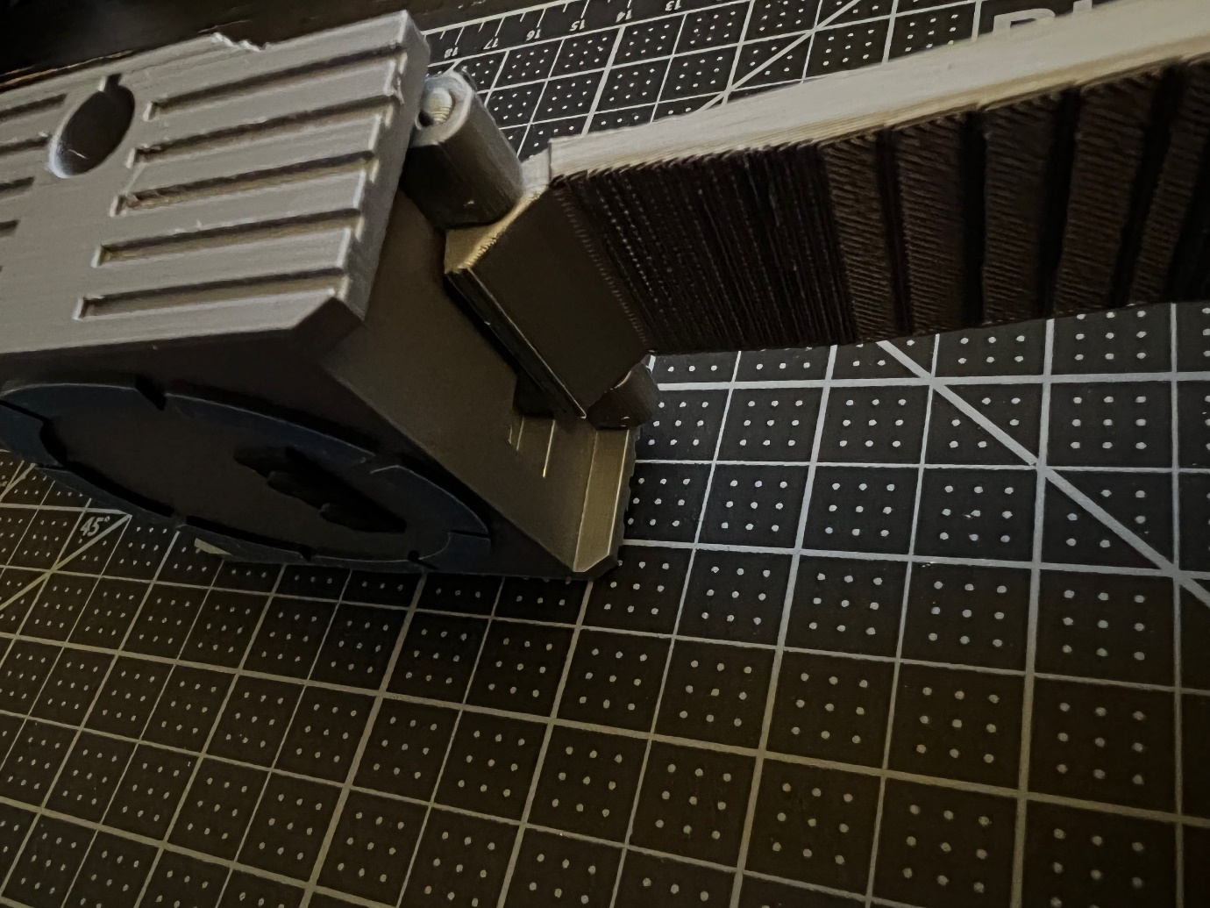

The fore shield in place. The slot we see under it is where the star trackers will go.

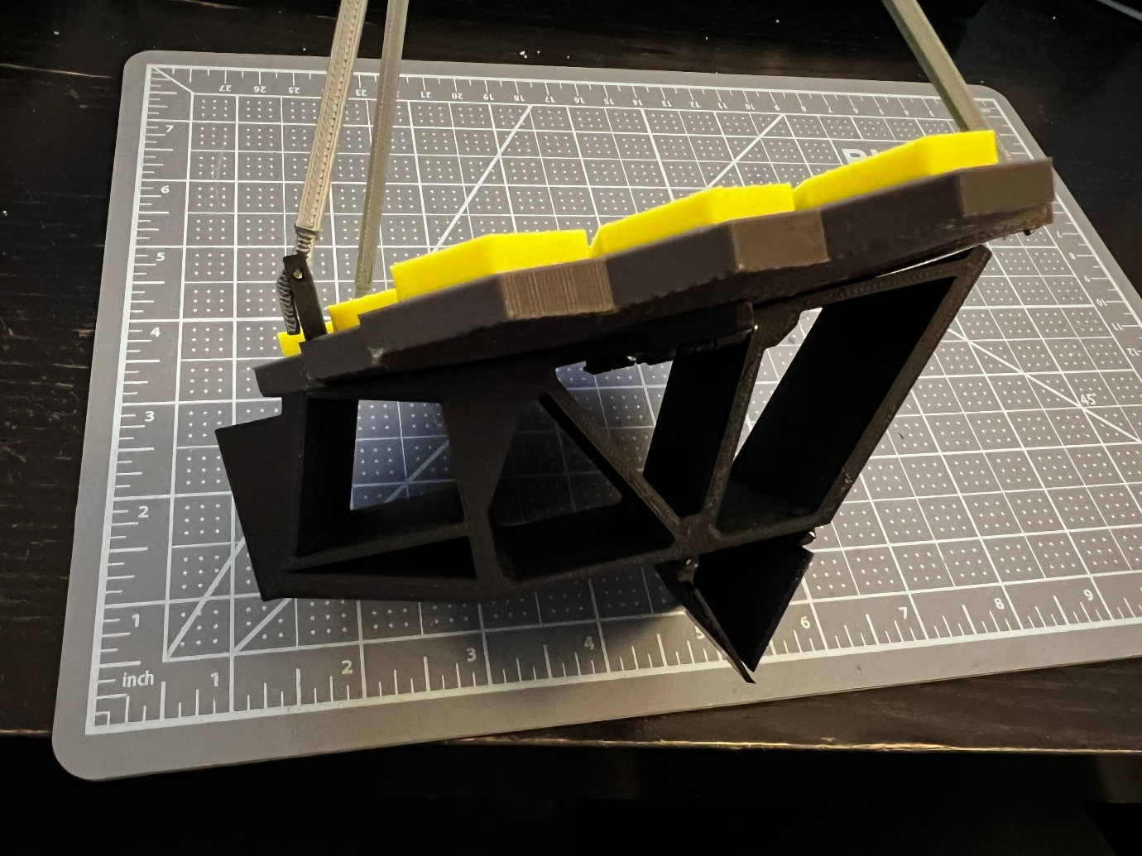

Connect the central mirror element to the mirror scaffold. There was a lot of friction that held it in place for me; if this isn’t the case with your print, you could glue them together.

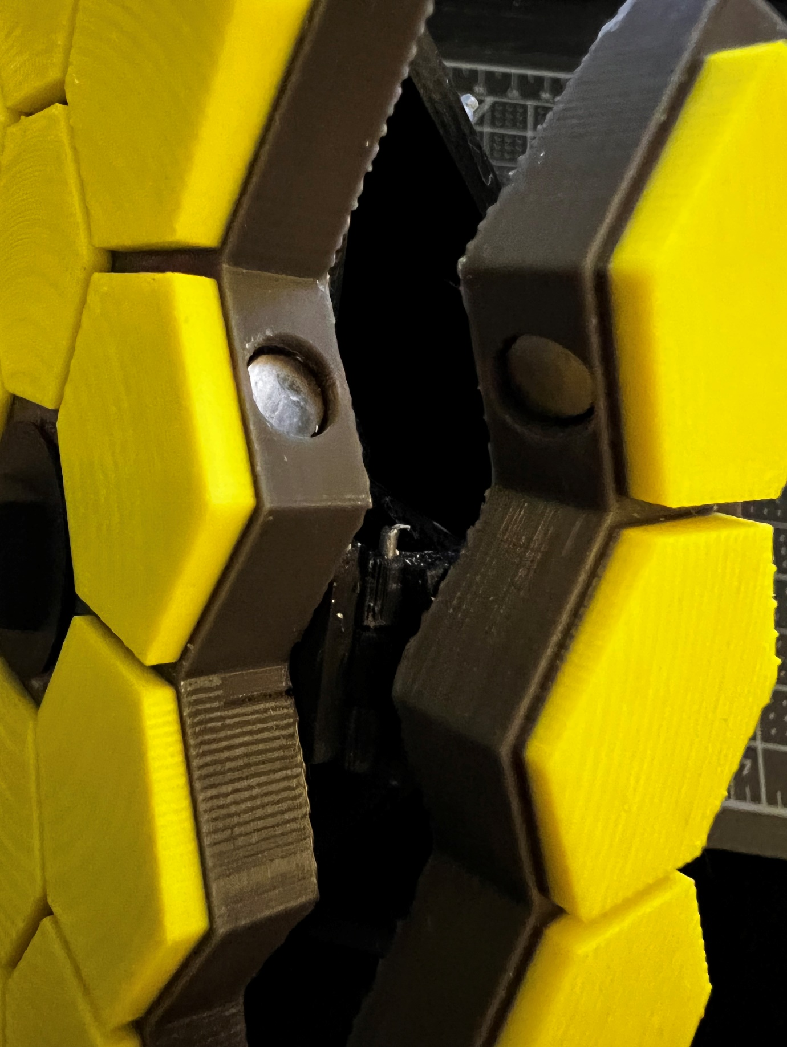

At this point you can also glue some magnets in the holes present in all 3 mirror elements. Make sure to get the polarity right, otherwise they’ll push against each other instead of keeping the mirror elements in place.

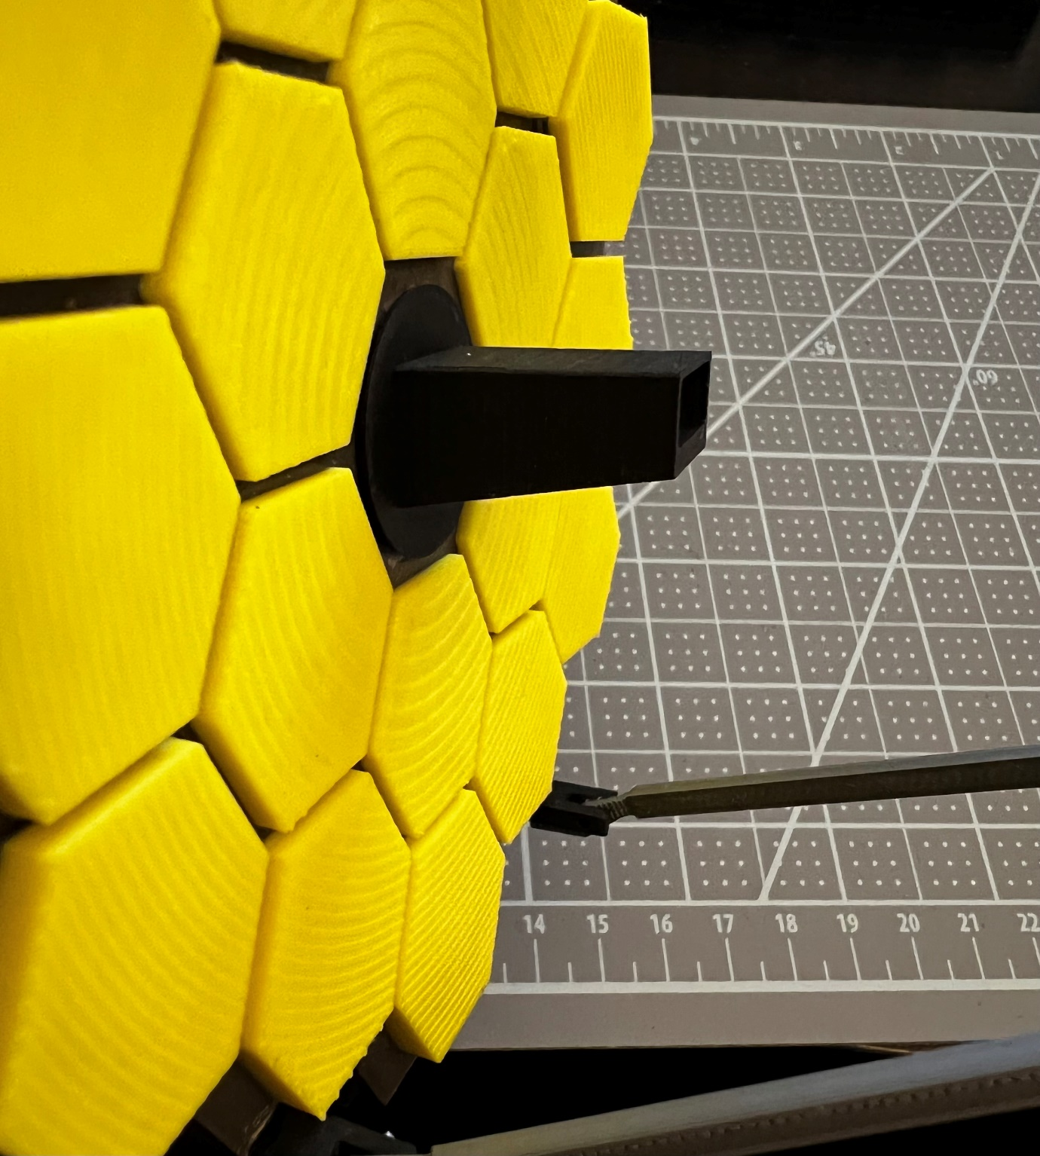

This would also be a good time to glue the light collector to the central mirror element. It goes a certain way: the flat side should be at the top, while the one that’s "rising" should be underneath.

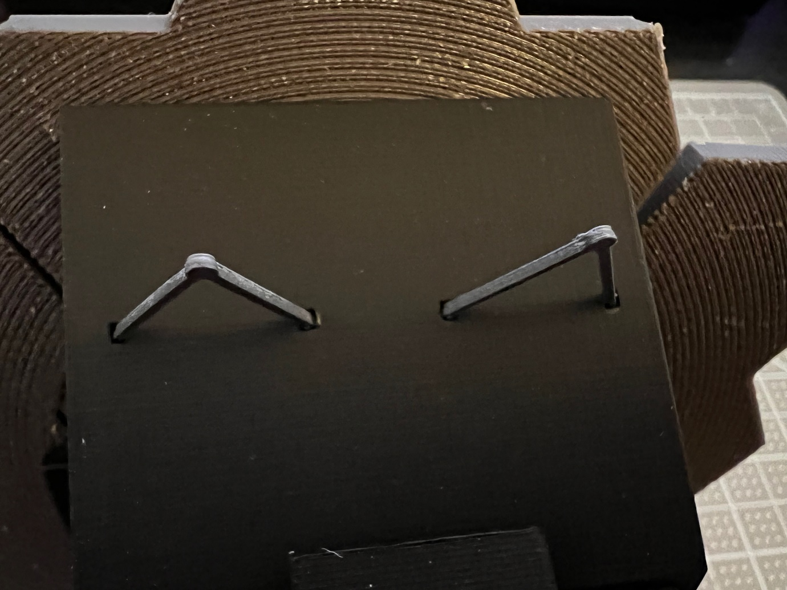

Add these two tiny struts that look like wishbones (bak-of-mirror-strut-2x.stl) to the mirror scaffold.

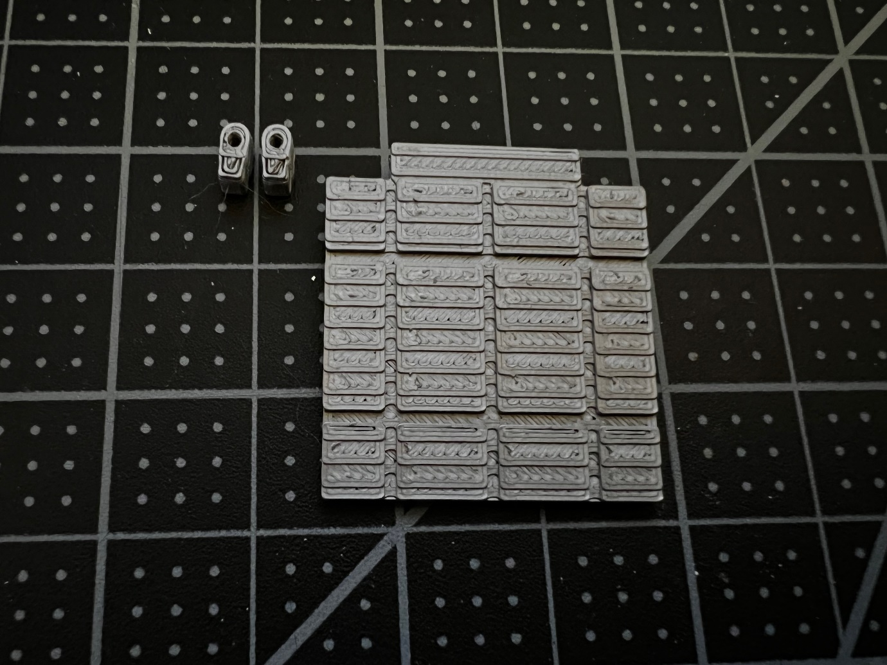

Take the aft flap (aft-momentum-flap.stl) and its two tiny connectors and attach them underneath the aft shield.

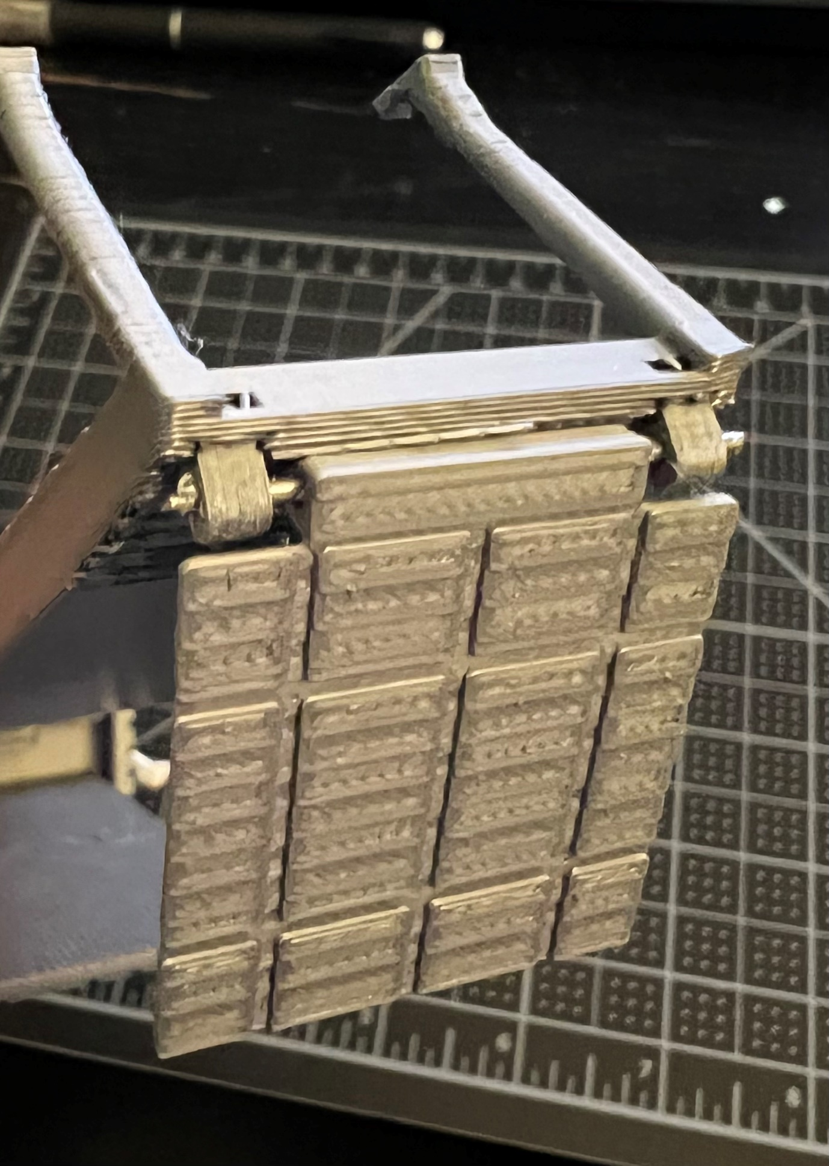

In place, and with a piece of wire for the hinge.

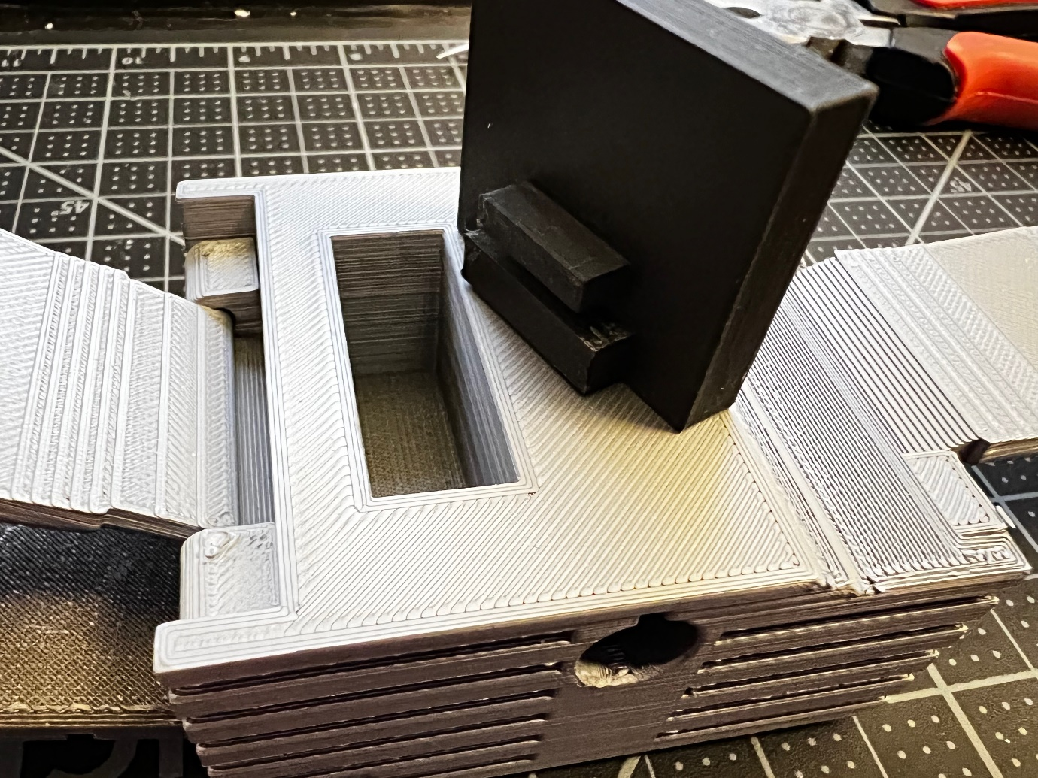

Attach the mirror tower to the main body. I glued it in place since there wasn’t enough friction to hold it and the structure it carries in place.

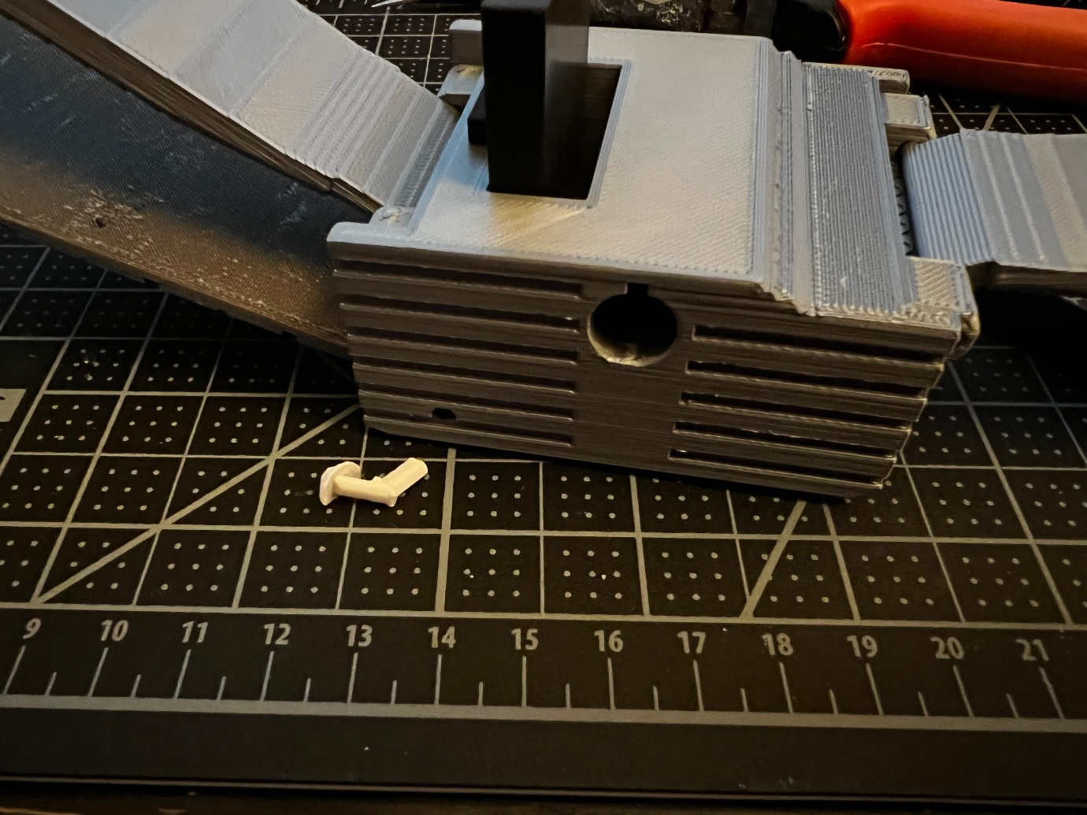

Mirror tower placed and glued. You could also attach the antenna now, or leave it as one of the last detail elements to put in. In any case, here’s where it goes.

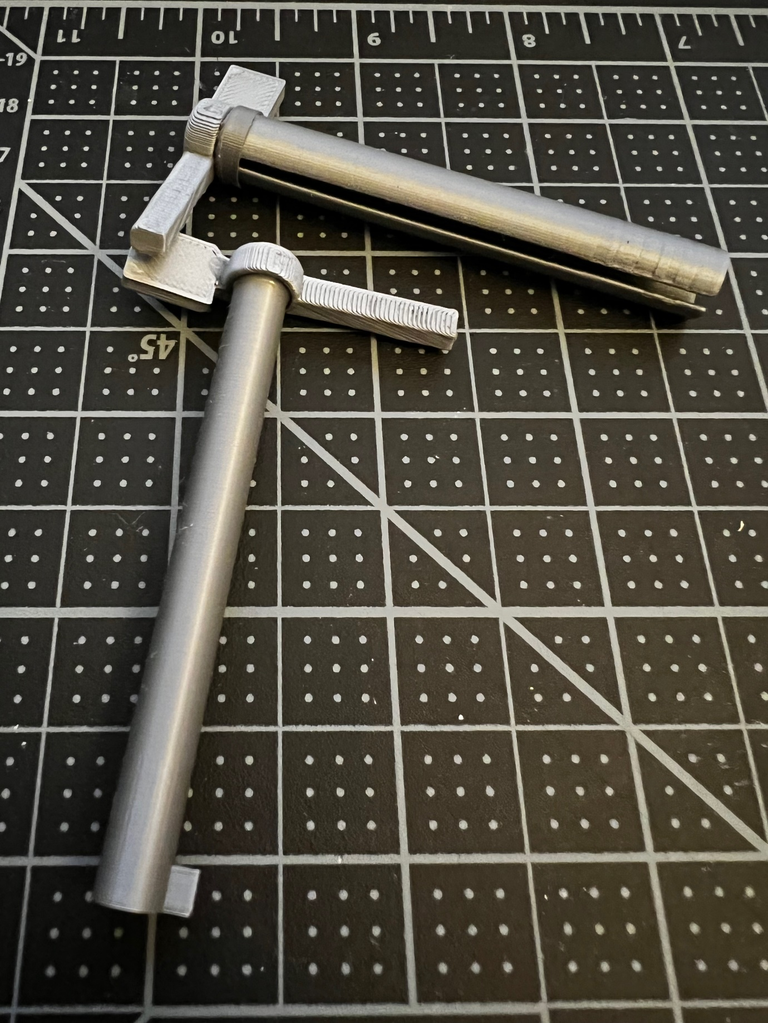

Glue the boom end posts to the left and right booms. Note that the booms do not have the same diameter, and that’s because the right boom fits inside the left boom. The right boom is glued directly to its end post, but the left boom (with the slit) needs an extra element in-between (left-boom-cap.stl)

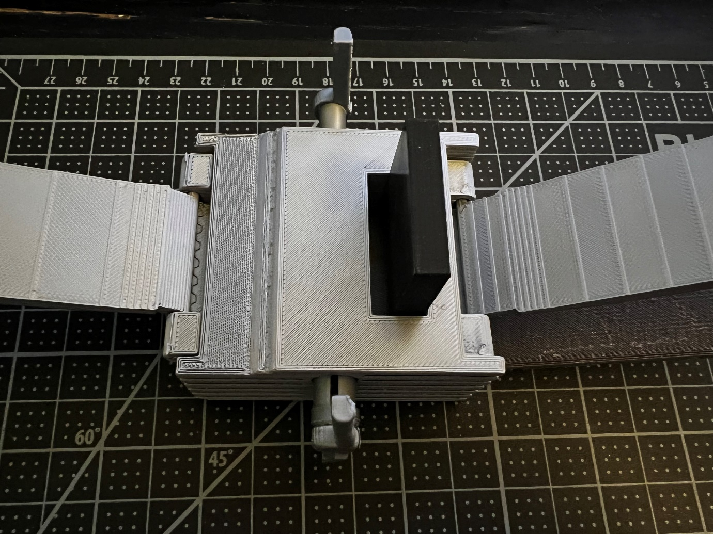

Insert the two boom arms. Here, the front of the telescope is to the left, and the arms are shown inserted

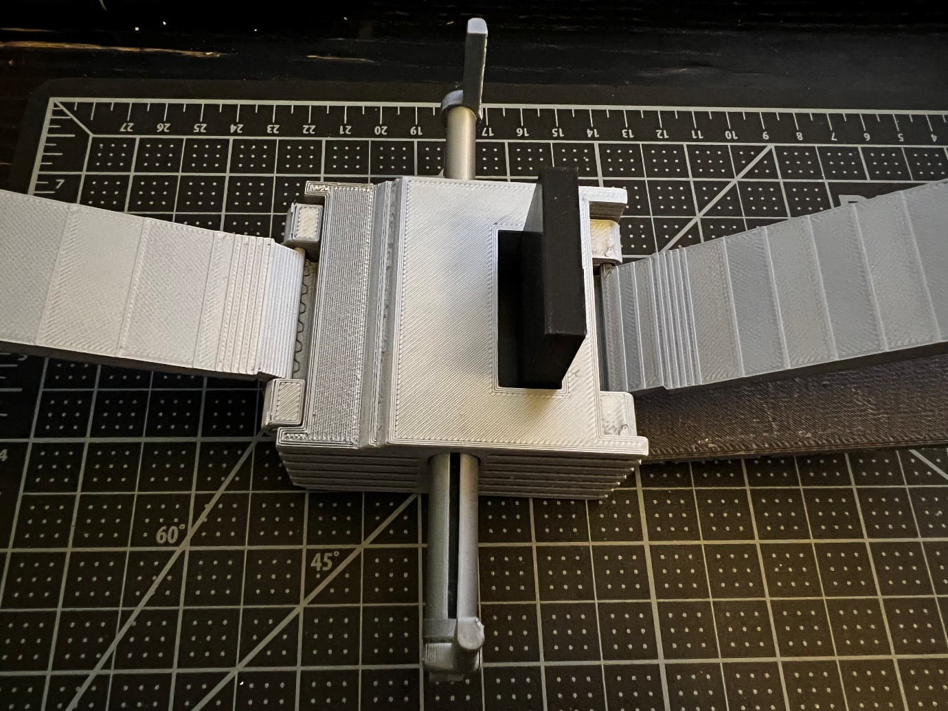

Same angle, with the boom arms extended.

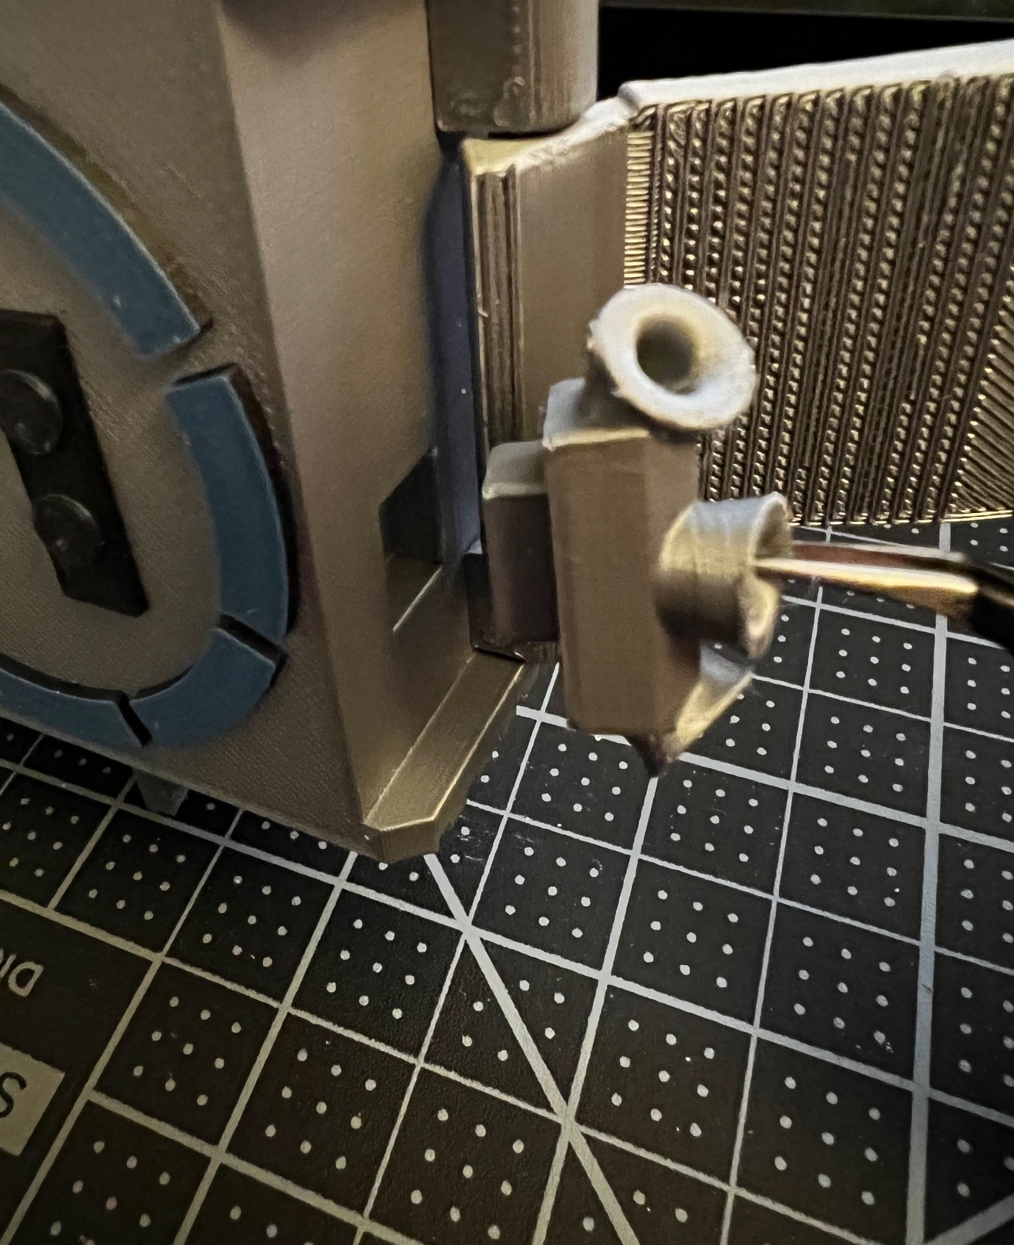

Attach the star trackers on the front side of the main body element. I chose to glue the two together.

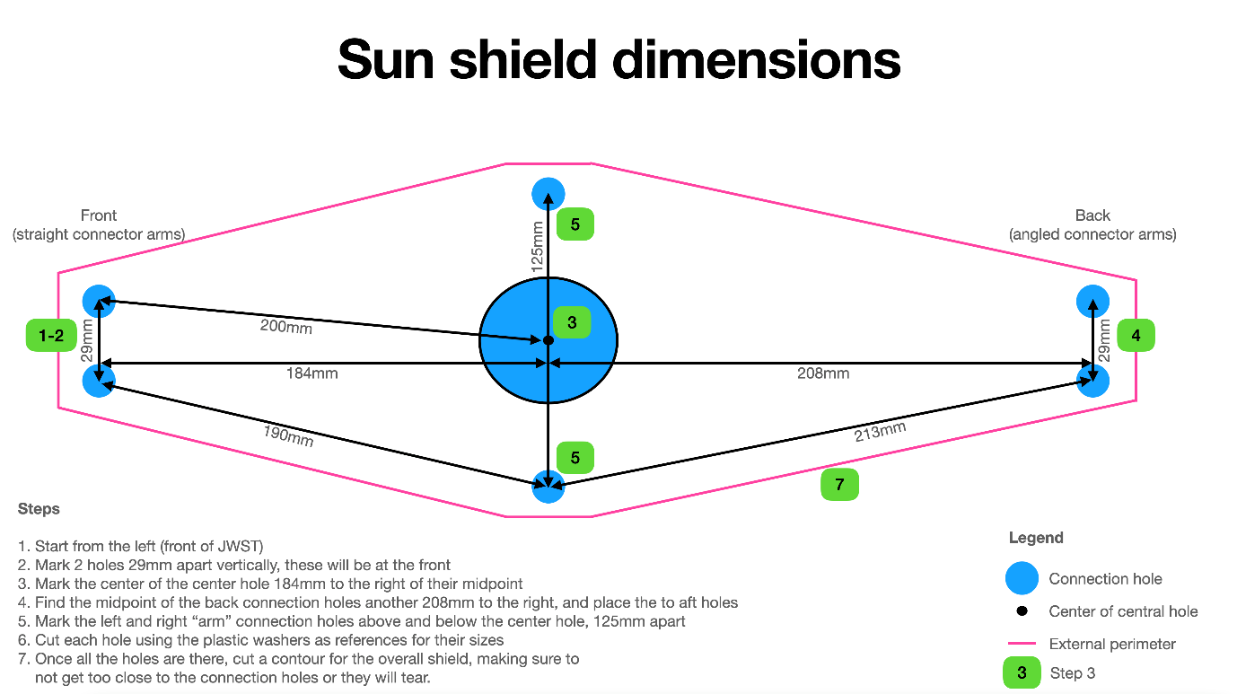

I used a ruler to measure distances between various elements on the printed base structure once assembled (without the top half mounted on). Follow the steps on this image to create a cutout of the sun shield. ⚠️ The dimensions presented here are not the *widest* configuration you could use. I chose these dimensions because if you extend the boom arms too far out, it’s easy for them to just fall out. I found that having a distance of 125 mm between their "posts" was a good compromise, but I would suggest you play around with various levels of extension for the boom arms, and find the width that you want for your model. You could definitely make it wider, just be careful not to go too wide. This image doesn’t provide exact dimensions for the external perimeter, just the holes. Don’t worry about it too much, just make sure to add enough margin that the holes are not too close to the edge or you’d risk having them rip and have a tear connect to the outer edge.

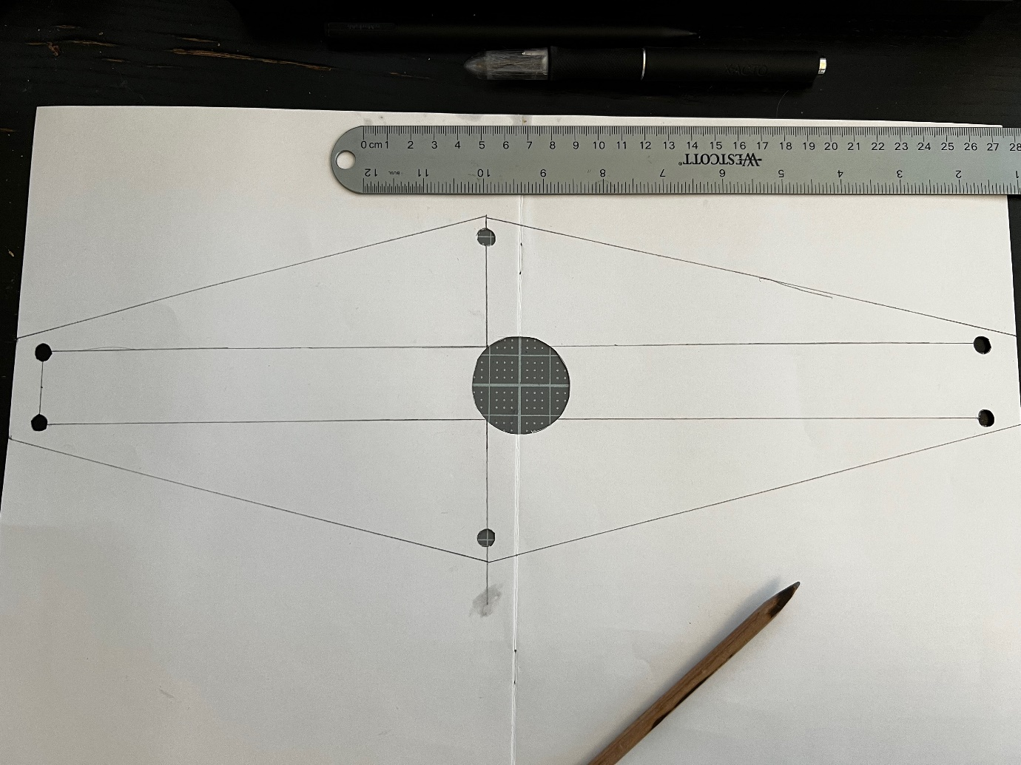

For a test fit, I first cut out the shape of the sun shield on a large piece of paper.

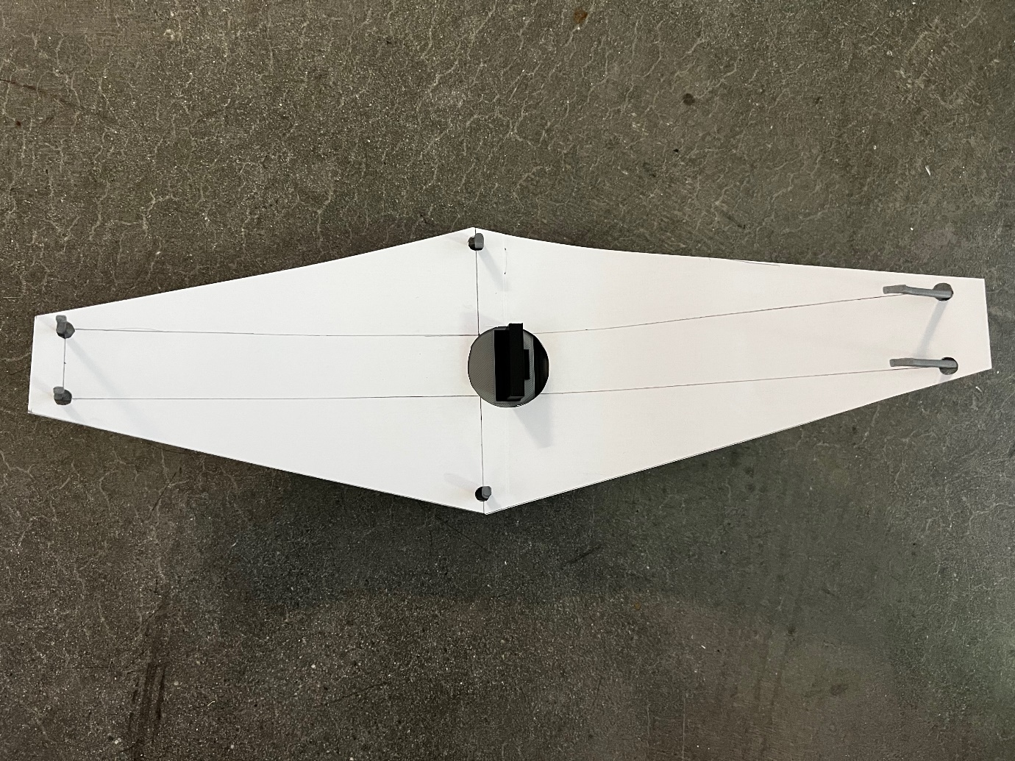

The paper shield fits well! Next, the mylar version. You can probably find mylar foil at your local arts & crafts store. If you can’t find mylar locally, Amazon does sell it although it’s not cheap at $17/roll: https://amazon.com/gp/product/B004BNDHUM To cut the mylar version, I used the paper shield as a template and marked where the holes would go: for the 6 outer holes I only marked a dot in the center of each hole, and drew the circumference of the inner hole using the central washer as a guide. With all the holes marked, I cut the outer perimeter using a hobby knife. I then glued all the washers in place, first on one side and then on the other once the glue had dried. Finally, I cut the central hole close to the washer and then tiny square holes for the 6 corners *inside* of the glued washers.

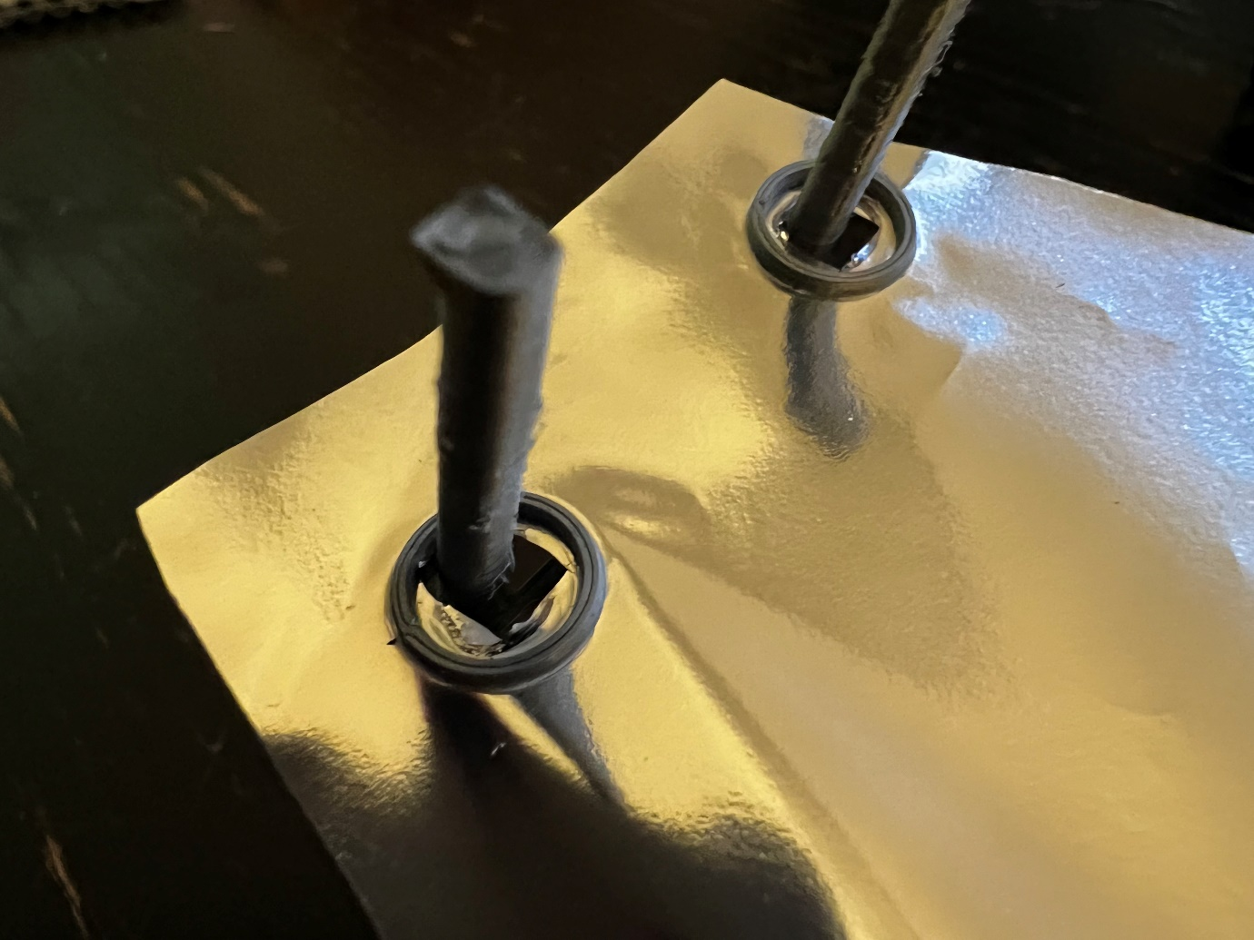

Close-up of how I cut the holes inside of the washers. Be careful not to extend the cut outside of these rings or the whole shield could tear.

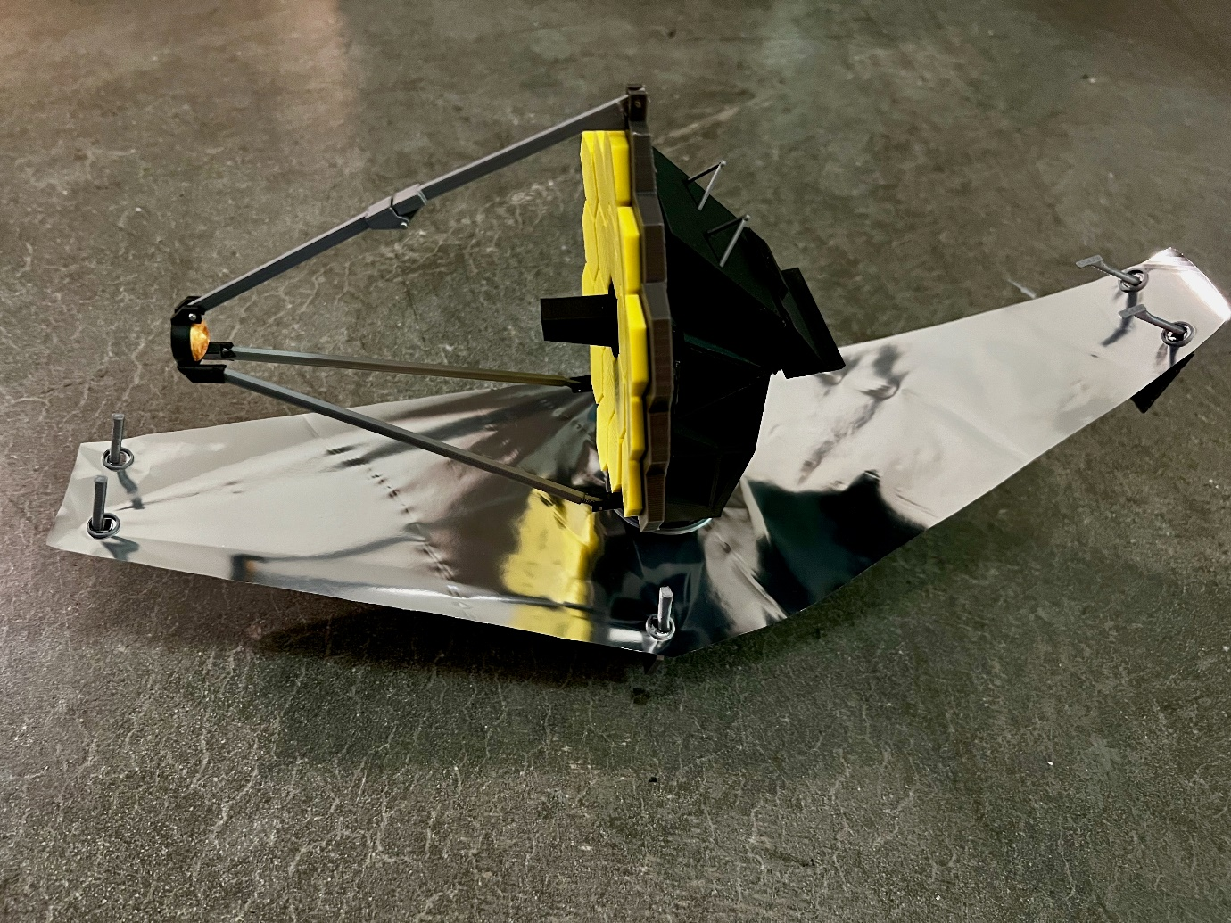

Final build!

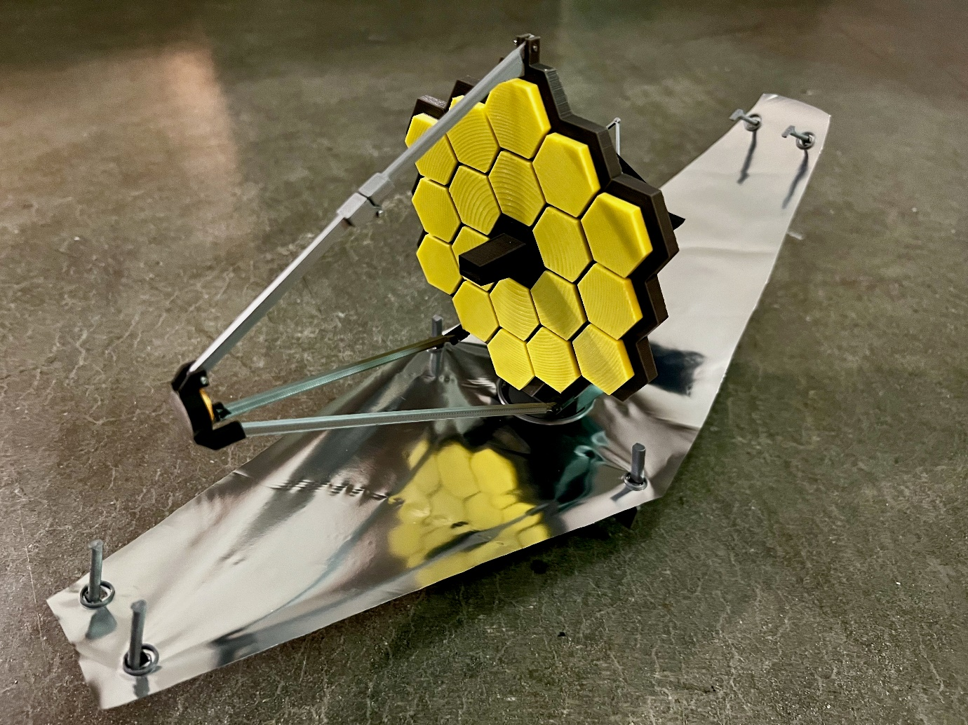

Different angle.

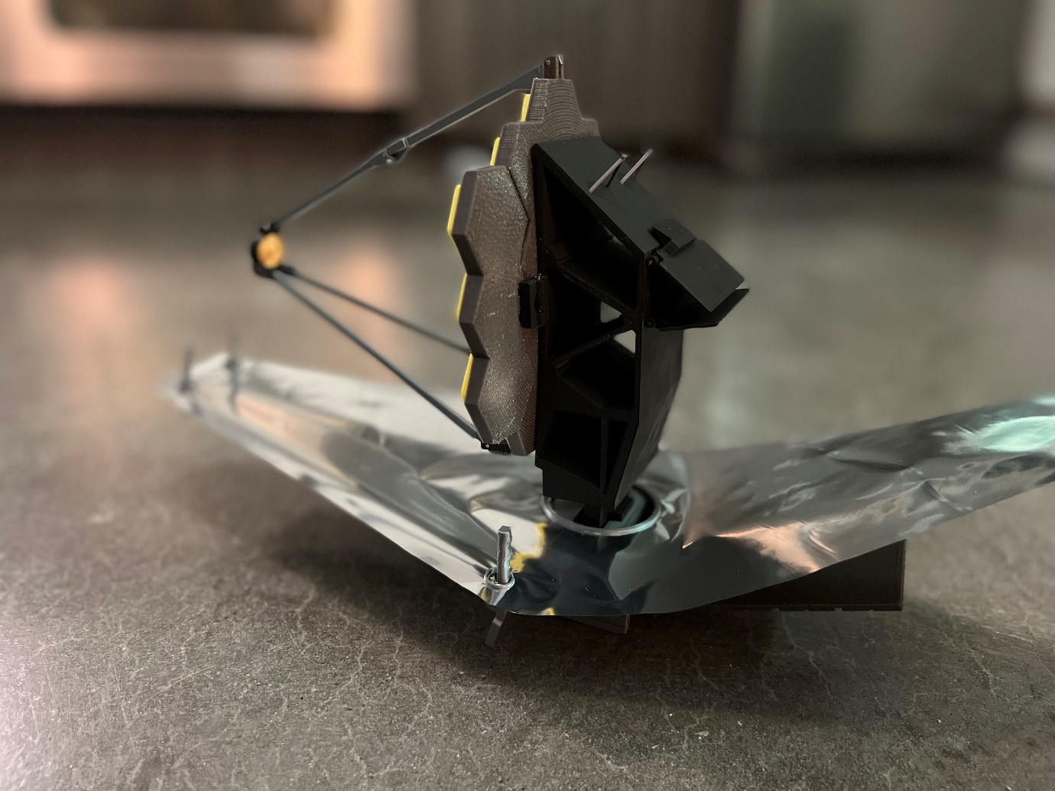

From the back.

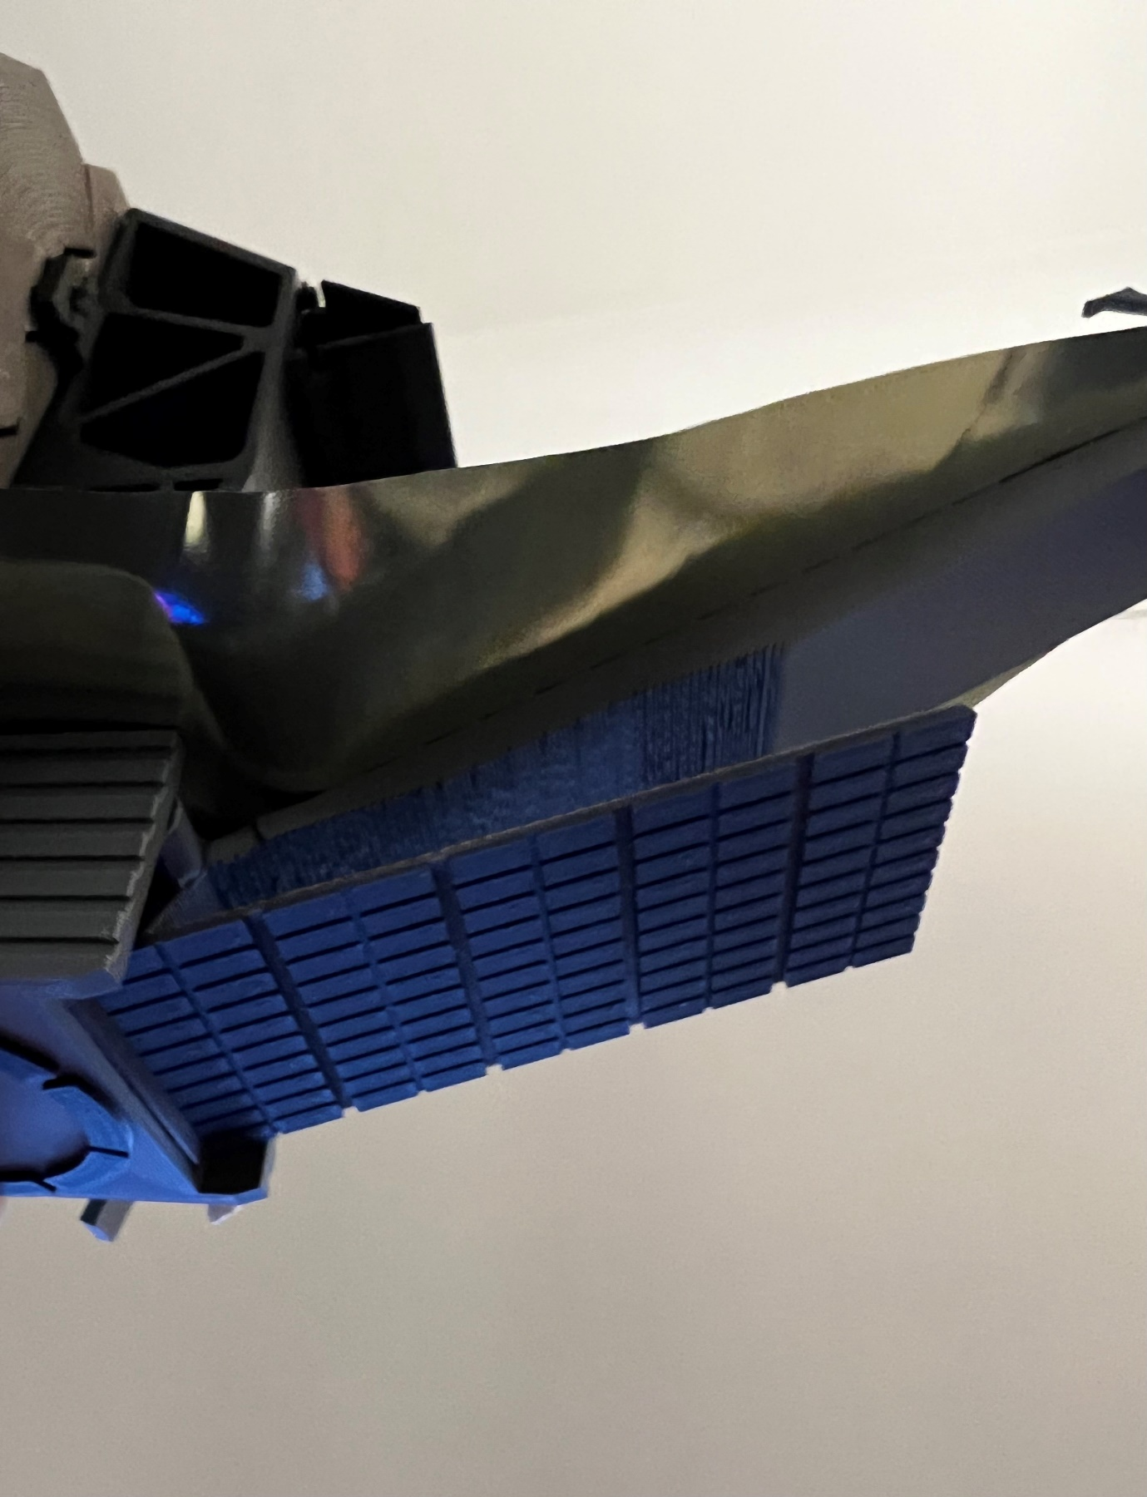

Solar panel from underneath.

